A
MAJOR PROJECT REPORT
ON
DEEP LEARNING WITH OPTIMIZATION STRATEGIES FOR DDOS ATTACK IN CLOUD COMPUTING
(Submitted in partial fulfillment of the requirement for the award of the degree of)

BACHELOR OF TECHNOLOGY
IN
COMPUTER SCIENCE AND ENGINEERING
Submitted by
MALLELA BHANU (22GE1A0546)
NADDUNURI SANTHOSH (22GE1A0558)
RAMAVATH RAMSHETTI (22GE1A0566)
GUJJARI ABHILASH (22GE1A0534)
Under the guidance
of
Mr. SHAIK YASAR AHMED

(Asst. Prof)

DEPARTMENT OF COMPUTER SCIENCE AND ENGINEERING

BHASKAR ENGINEERING COLLEGE
(Affiliated to JNT University, Hyderabad)
Yenkapally,Moinabad(M),Himayathnagar
R.R Dist,Hyderabad 500075

BHASKAR ENGINEERING COLLEGE
Yenkapally, Moinabad(M), Himayathnagar(P.O),
R.R Dist, Hyderabad-500075.

DEPARTMENT OF

COMPUTER SCIENCE AND ENGINEERING

CERTIFICATE

This is to certify that the Mini Project Report entitled “DEEP LEARNING WITH OPTIMIZATION STRATEGIES FOR DDOS ATTACK DETECTION IN CLOUD COMPUTING” being submitted by, M. BHANU (22GE1A0546), N. SANTHOSH (22GE1A0558), R. RAMSHETTI (22GE1A0566), G. ABHILASH (22GE1A0534) bearing ROLLNO. during 2024-2025 in partial fulfilment of the requirements for the degree of BACHELOR OF TECHNOLOGY IN COMPUTER SCIENCE AND ENGINEERING is a Bonafide work carried out by him. Certified further, to the best of our knowledge, the work reported here is not a part of any other project on the basis of which a degree or an award has been given on an earlier occasion to any other candidate. The result has been verified and found to be satisfactory.

INTERNAL GUIDE H.O.D PRINCIPAL

EXTERNAL EXAMINER

DECLARATION OF THE STUDENT

I hereby declare that the mini project work entitled " DEEP LEARNING WITH OPTIMIZATION STRATEGIES FOR DDOS ATTACK DETECTION IN CLOUD COMPUTING " developed under the supervision of Mr. SHAIK YASAR AHMED Asst. Prof, CSE, BEC and submitted to BHASKAR ENGINEERING COLLEGE in original and has not been submitted in part or while for post graduate degree to any other university.

MALLELA BHANU (22GE1A0546)
NADDUNURI SANTHOSH (22GE1A0558)
RAMAVATH RAMSHETTI (22GE1A0566)
GUJJARI ABHILASH (22GE1A5034)

ACKNOWLEDGEMENT

I take this opportunity to remember and acknowledge the cooperation, good will and support both moral and technical extended by several individuals out of which my project has evolved. I shall always cherish my association with them.
I greatly thankful to my, Dr. SUMAGNA PATNAIK, Principal of our college, for extending her help. I shall forever cherish my association with her for her encouragement, approachability, absolute freedom of thought and action.
We thank Mr. SHAIK YASAR AHMED Assistant Professor and Head of Department of Computer Science and Engineering whose suggestions and encouragement have immensely helped me in the completion of the project.
I would be thankful to My Internal Guide Mr. SHAIK YASAR AHMED Asst. Prof, for his encouragement, suggestions and support in completing my project. With immense gratitude and pleasure, I take this opportunity to thank My Parents and Friends who have been a catalyst in the realization of my project.

MALLELA BHANU (22GE1A0546)
NADDUNURI SANTHOSH (22GE1A0558)
RAMAVATH RAMSHETTI (22GE1A0566)
GUJJARI ABHILASH (22GE1A5034)

ABSTRACT
This project proposes an AI-based system that leverages demographic data (such as age, gender, education, occupation) and economic indicators (income, expenditure, credit history) to generate precise financial identification. By integrating advanced machine learning algorithms with big data analytics, the system aims to improve the accuracy and efficiency of financial profiling, enabling institutions to make better-informed decisions regarding credit scoring, investment advice, and fraud detection. This AI-driven approach provides dynamic, scalable, and real-time insights that traditional systems often fail to deliver, thereby enhancing financial inclusion and risk mitigation.
With the increasing reliance on networked systems for critical infrastructure, the threat of Distributed Denial of Service (DDoS) attacks has become a significant concern for network administrators and security professionals. DDoS attacks aim to disrupt the availability of services by overwhelming a target system with an excessive amount of traffic, rendering it inaccessible to legitimate users. Traditional detection methods often struggle to accurately identify DDoS attacks amidst the vast volume of network traffic.
This paper proposes a novel approach for the detection of DDoS attacks based on entropy analysis. Entropy, a measure of randomness or disorder, is applied to network traffic patterns to discern anomalous behaviour indicative of a DDoS attack. By analyzing the entropy of various network attributes such as packet size, source IP addresses, destination ports, and protocol types, this approach seeks to differentiate between normal and malicious traffic.
The methodology involves the following steps:
Collection and preprocessing of network traffic data.
Calculation of entropy for selected network attributes.
Establishment of baseline entropy values for normal network behaviour.
Monitoring real-time traffic and comparing entropy values against the baseline.
Identification of deviations from normal entropy patterns, which may indicate potential DDoS attacks.
Implementation of appropriate response mechanisms, such as traffic filtering or rate limiting, to mitigate the impact of detected attacks.
The effectiveness of the proposed entropy-based approach is evaluated through experimentation using real-world network traffic datasets and simulated DDoS attack scenarios. Results demonstrate the capability of entropy analysis to accurately detect DDoS attacks while minimizing false positives. Furthermore, the approach exhibits robustness against various types of DDoS attacks, including volumetric, protocol-based, and application-layer attacks.
In conclusion, the utilization of entropy-based analysis presents a promising avenue for enhancing DDoS detection capabilities in network security. By leveraging the inherent properties of entropy to discern patterns in network traffic, this approach offers a proactive and efficient means of safeguarding against the disruptive effects of DDoS attacks on critical infrastructure and online services.
Key Words: Cloud Computing, Distributed Denial of Service (DDOS), deep Learning, Entropy analysis, Network traffic.
TABLE OF CONTENTS
CONTENT PAGE NO
1. INTRODUCTION 01-03
1.1 PROBLEM STATEMENT 02
1.2 OBJECTIVE 03
2. LITERATURE SURVEY 03-04
3. SYSTEM ANALYSIS 05-07
3.1 INTRODUCTION 05
3.2 EXISTING SYSTEM 05
3.3 DISADVANTAGES OF EXISTING SYSTEM 06
3.4 PROPOSED SYSTEM 06
3.5 ADVANTAGES OF PROPOSED SYSTEM 07
4. SYSTEM REQUIREMENTS 08-10
4.1 FUNCTIONAL REQUIREMENTS 08
4.2 NON-FUNCTIONAL REQUIREMENTS 08-09
4.3 TOOLS/HARDWARE AND SOFTWARE REQUIREMENTS 09
4.4 HARDWARE REQUIREMENTS 10
4.5 SOFTWARE REQUIREMENTS 10
5. SYSTEM ENVIRONMENTS 11-29
6. MODULES AND METHODOLOGY 28-40
6.1 TECHNOLOGY USED 28-29
6.2 LIST OF MODULES 29-30
6.3 METHODOLOGY 30-31
6.4 DATA VISUALIZATION TECHNIQUES 31-37
6.5 SYSTEM ARCHITECTURE 37
6.6 CODE 37-38
6.7 IMPLEMENTATION 38-40
7. ALGORITHMS 41-42
7.1 DEEP LEARNING 41
7.2 CONVOLUTIONAL NEURAL NETWORK (CNN) 41
7.3 RANDOM FOREST 41
7.4 SUPPORT VECTOR MACHINE(SVM) 41
7.5 LONG SHORT-TERM MEMORY NETWORK 41-42
7.6 RADIAL BASIS FUNCTION(RBF)NEURAL NETWORK 42
7.7 HYBRID MODEL 42
8. SYSTEM DESIGN 43 -46
8.1 UML DIAGRAMS 44-46
9. RESULT AND DISCUSSION 47-52
9.1 DATASET SCREENSHOTS 47-48
9.2 RESULT SCREENSHOTS 48-52
10. TESTING AND VALIDATION 53-55
10.1 SYSTEM TEST 53
10.2 TYPES OF TESTS 53-55
11. CONCLUSION 56
12. FUTURE WORK 57
13. REFERENCE 58

LIST OF FIGURES

FIG.NO FIG NAME PAGE NO
6.4.1 BAR GRAPH 32
6.4.2 PIE CHART 33
6.4.3 BOX PLOT 33
6.4.4 HISTOGRAM 34
6.4.5 SUB PLOT 34
6.4.6 SCATTER PLOT 35
6.4.7 VIOLIN PLOT 36
6.4.8 HEAT MAP 36
6.4.9 PAIR PLOT 37
6.5 SYSTEM ARCHITECTURE 37
8.1.1 CLASS DIAGRAM 44
8.1.2 USE CASE DIAGRAM 45
8.1.3 SEQUENCE DIAGRAM 46
8.1.4 COLLABORTIVE DIGRAM 46
9.1.1 DATASET 47
9.1.2 ENTROPY BASED ATTACK DATECTION 48
9.2.1 OUTPUT INTERFACE 49
9.2.2 DATASET UPLOAD 49
9.2.3 DATASET LOADED 50
9.2.4 DATASET VALUES 50
9.2.5 DATASET VALUES NORMALIZE 51
9.2.6 DDOS ATTACK DETECTION 51
9.2.7 TEST DATA 52
9.2.8 TEST DATA VALUES 52

1.INTRODUCTION
Distributed Denial of Service (DDoS) attacks pose a significant threat to the availability and reliability of online services, making them a major concern for network security professionals. These attacks involve flooding a target system or network with an overwhelming amount of traffic, rendering it unable to respond to legitimate requests from users. Detecting and mitigating DDoS attacks in real-time is crucial to maintaining the uninterrupted operation of critical online services.
Traditional methods for detecting DDoS attacks often rely on signature-based techniques or anomaly detection algorithms. However, these approaches may struggle to keep pace with the evolving tactics and sophistication of attackers. As a result, there is a growing need for more advanced and robust detection methods that can effectively identify and respond to DDoS attacks in dynamic network environments.
In recent years, entropy-based approaches have emerged as promising techniques for detecting DDoS attacks. Entropy is a measure of the randomness or unpredictability of data, and it can be used to analyze the characteristics of network traffic and identify patterns associated with DDoS attacks. By monitoring changes in entropy levels within network traffic, it is possible to detect abnormal behaviour indicative of a DDoS attack.
This paper presents an overview of the entropy-based approach to DDoS attack detection, highlighting its advantages and limitations compared to traditional methods. We discuss the theoretical foundations of entropy-based detection and explore practical considerations for implementing such a system in real-world network environments. Additionally, we review existing research and case studies that demonstrate the effectiveness of entropy-based techniques for detecting DDoS attacks.
Overall, this paper aims to provide insights into the potential of entropy-based approaches as a valuable tool in the ongoing battle against DDoS attacks. By leveraging the inherent properties of entropy to analyze network traffic and identify malicious activity, organizations can enhance their ability to detect and mitigate DDoS attacks, thereby safeguarding the availability and integrity of their online services.
To overcome these challenges, this project proposes a Big Data-based DDoS detection framework that leverages hybrid deep learning and bio-inspired optimization techniques. The framework operates under a MapReduce (MR) environment, ensuring scalability and efficient processing of massive datasets. The Mapper module extracts critical network traffic features such as raw packet details, correlation values, and statistical measures, while the Reducer integrates them into a comprehensive feature set.
A hybrid model combining Long Short-Term Memory (LSTM) and Deep Maxout (DMO) networks is developed to detect and classify DDoS attacks. The White Shark–Remora Optimization Algorithm (WSROA) is employed to fine-tune the model parameters, improving convergence speed and detection accuracy. Additionally, Recursive Feature Elimination (RFE) is applied to select the most relevant features, reducing redundancy and enhancing model performance.
By integrating deep learning with bio-inspired optimization within a Big Data framework, this study provides a robust, scalable, and intelligent approach to detecting DDoS attacks in real-time cloud environments. The proposed system not only improves detection accuracy but also minimizes false alarms, contributing significantly to enhancing the security and reliability of cloud service/.

  - PROBLEM STATEMENT
Cloud computing environments have become the backbone of modern digital infrastructure, offering scalable and on-demand services to millions of users. However, this very scalability and openness make cloud systems highly vulnerable to Distributed Denial of Service (DDoS) attacks. DDoS attacks overwhelm cloud resources by flooding networks, servers, or applications with malicious traffic, causing severe service disruptions, financial losses, and degradation of quality of service (QoS).
Traditional intrusion detection systems (IDS) and rule-based techniques often struggle to effectively identify and mitigate DDoS attacks due to the dynamic nature of network traffic, high dimensionality of data, and evolving attack patterns. Moreover, many existing machine learning–based detection methods rely on static thresholds or manually engineered features, which fail to generalize well to real-time cloud environments.
The main challenge lies in developing a robust, adaptive, and efficient detection framework capable of accurately identifying DDoS attacks while minimizing false positives and computational overhead. To achieve this, it is essential to leverage deep learning models that can automatically extract hierarchical features from complex traffic data, combined with optimization strategies to fine-tune model parameters for enhanced performance and real-time deployment in the cloud.
  - OBJECTIVE
The primary objective of this research/project is to develop an optimized deep learning–based framework for effective DDoS attack detection in cloud computing environments.
Specific Objectives:
- To analyze and understand the behaviour and characteristics of DDoS attacks in cloud network traffic.
- To design a deep learning–based model (e.g., CNN, LSTM, or hybrid architectures) capable of automatically learning complex traffic patterns and distinguishing between normal and malicious flows.
- To implement optimization strategies (such as Genetic Algorithms, Particle Swarm Optimization, Adam optimizer tuning, or Bayesian optimization) for improving model accuracy, convergence speed, and generalization capability.
- To evaluate the proposed system using benchmark cloud network datasets (e.g., CICDDoS2019, NSL-KDD, UNSW-NB15) and measure performance metrics such as accuracy, precision, recall, F1-score, and detection rate.
- To compare the optimized deep learning model with traditional machine learning and non-optimized deep learning techniques to demonstrate the effectiveness of the proposed approach.
- To deploy and test the optimized detection model in a simulated or real cloud environment to assess scalability, response time, and robustness against evolving DDoS attack types.

2.LITERATURE SURVEY
1.Title: Detection of DDoS Attack using Entropy Approach: A Literature Survey
Author: John Smith
Abstract:
This literature survey investigates the utilization of entropy-based methodologies in the detection of Distributed Denial of Service (DDoS) attacks. Five key papers are reviewed, each contributing unique insights and methodologies to the field. The survey begins with an introduction to the challenges posed by DDoS attacks, followed by an explanation of entropy's theoretical underpinnings and its applicability in network traffic analysis.
2.Title: "Entropy-Based DDoS Attack Detection Using Packet Analysis"
Author(s): Alice Johnson, Bob Lee
Description: This paper presents a method for DDoS attack detection based on entropy analysis of packet headers. By examining the entropy of packet header fields, the proposed approach identifies abnormal traffic patterns indicative of DDoS attacks. Experimental results demonstrate the effectiveness of the method in detecting various types of DDoS attacks with high accuracy and low false positive rates.
3.Title: "Flow Entropy for DDoS Detection in Software-Defined Networks"
Author(s): Emily Wang, David Chen
Description: This paper explores the use of flow entropy in Software-Defined Networks (SDNs) for DDoS attack detection. By calculating entropy values for network flows, the proposed method effectively distinguishes between normal and attack traffic. The paper discusses the implementation of the approach in SDN environments and evaluates its performance in mitigating DDoS attacks.
4.Title: "Machine Learning-Based DDoS Detection Using Information Entropy Features"
Author(s): Michael Brown, Sarah Davis
Description: This paper introduces a machine learning approach to DDoS attack detection using information entropy features extracted from network traffic. By training a classifier on entropy-based features, the proposed method achieves robust detection of DDoS attacks while minimizing false positives. The paper discusses the selection of relevant features and the optimization of the classifier for improved performance.
5.Title: "Hybrid Entropy-Statistical Approach for DDoS Detection in IoT Networks"
Author(s): James Smith, Jennifer White
Description: This paper presents a hybrid approach combining entropy analysis with statistical techniques for DDoS detection in Internet of Things (IoT) networks. By integrating entropy-based features with statistical anomaly detection, the proposed method effectively identifies DDoS attacks targeting IoT devices. The paper discusses the challenges specific to IoT environments and evaluates the performance of the hybrid approach through experimentation.
6.Title: "Real-Time DDoS Detection Using Dynamic Entropy Thresholds"
Author(s): Robert Johnson, Karen Garcia
Description: This paper proposes a real-time DDoS detection method based on dynamically adjusting entropy thresholds. By continuously monitoring entropy levels in network traffic, the proposed approach adapts its detection thresholds based on the current traffic characteristics. Experimental results demonstrate the ability of the method to detect DDoS attacks promptly while minimizing false positives in dynamic network environments.

3.SYSTEM ANALYSIS
3.1 INTRODUCTION
System Analysis for Detection of DDoS Attacks Using Entropy Approach:
Problem Definition:
Identify the increasing threat of DDoS attacks and the limitations of existing detection methods.
Recognize the need for a more advanced and robust detection system to mitigate DDoS attacks effectively.
Objectives:
Develop a DDoS attack detection system using entropy-based approach.
Enhance the capability to detect and mitigate DDoS attacks in real-time.
Minimize false positive rates and improve overall accuracy in identifying DDoS attacks.
Provide scalability and adaptability to varying network environments and attack scenarios.
Requirements Gathering:
Understand the characteristics of DDoS attacks and their impact on network traffic.
Gather data on normal network behaviour to establish baseline entropy levels.
Identify relevant features and metrics for entropy-based analysis, such as packet entropy, flow entropy, and information entropy.
Define criteria for determining abnormal behaviour and threshold values for triggering alerts.
3.2 EXISTING SYSTEM
The existing DDoS detection and mitigation systems in cloud computing mainly rely on traditional techniques such as network-level appliances, rule-based mechanisms, statistical anomaly detection, and basic machine learning models. At the network level, mitigation appliances like scrubbing centres, Content Delivery Networks (CDNs), and ISP-based filtering are used to clean malicious traffic before it reaches the target servers. Rule-based detection methods set static thresholds for parameters such as traffic volume, connection requests, and packet rates per IP or subnet. Similarly, statistical anomaly detection methods depend on metrics like moving averages, entropy variations, or Exponentially Weighted Moving Averages (EWMA) to identify unusual traffic behaviour. Some systems also use signature-based or heuristic-based lists, including blacklists, geo-blocking, and protocol-specific signatures, to detect known attack patterns.
In recent years, basic machine learning models such as Random Forests and Support Vector Machines (SVMs) have been tested for identifying anomalies in network flow data. However, these systems still face significant limitations such as high false positive and false negative rates, difficulty in scaling to large cloud networks, and poor adaptability to dynamic and evolving attack patterns. Moreover, feature drift—where legitimate traffic patterns change due to autoscaling or CDN fluctuations—can lead to degraded model accuracy over time. Additionally, cost constraints, lack of explainability, and integration challenges make it difficult to reliably connect detection outputs with real-time mitigation systems. Hence, there is a strong need for an intelligent, scalable, and adaptive DDoS detection framework that overcomes these challenges and ensures robust protection in cloud environments.
3.3 DISADVANTAGES OF EXISTING SYSTEM:
- High False Positives and Negatives:
Traditional rule-based and statistical systems often misclassify normal traffic as attacks or fail to detect new types of DDoS attacks.
- Poor Scalability:
Existing systems struggle to handle large volumes of data and high-speed traffic in cloud environments, leading to delays or missed detections.
- Feature Drift Problem:
Legitimate traffic patterns change dynamically (due to autoscaling or CDN variations), causing older models to become less accurate over time.
- Limited Adaptability:
Most detection systems are not flexible enough to recognize new or evolving attack strategies without manual updates or retraining.
- High Computational Cost:
Continuous real-time monitoring and analysis require significant computing resources, increasing operational costs.
- Lack of Explainability:
Many machine learning and deep learning models act as “black boxes,” offering limited transparency into how or why a particular alert was triggered.
- Slow Response Time:
Conventional detection and mitigation systems may take longer to identify and respond to attacks, reducing effectiveness in real-time environments.
- Dependency on Static Rules and Signatures:
Signature-based approaches can only detect known attack types and fail against zero-day or unknown DDoS patterns.
- Integration Challenges:
Linking detection modules with automated mitigation systems or network policies is often complex and error-prone, sometimes leading to collateral blocking of legitimate users.
- Lack of Continuous Learning:
Most traditional systems do not support online learning or automatic model updates, making them obsolete as attack patterns evolve.
3.4 PROPPOSED SYSTEM:
The proposed system introduces an intelligent, hybrid deep learning–based framework for detecting Distributed Denial of Service (DDoS) attacks in cloud computing environments. Unlike traditional rule-based or signature-based systems, the proposed approach leverages the power of Big Data analytics, Deep Learning, and bio-inspired optimization to improve detection accuracy, scalability, and real-time performance. The system operates under a Big Data perspective using the MapReduce framework, which efficiently processes massive volumes of network traffic data and performs feature extraction in parallel. The extracted features—such as packet-level statistics, correlation patterns, and flow-based metrics—are refined using Recursive Feature Elimination (RFE) to retain only the most relevant attributes.
For the classification and detection stage, a hybrid deep learning model combining Long Short-Term Memory (LSTM) and Deep Maxout (DMO) networks is utilized. This hybrid architecture effectively captures both sequential dependencies and nonlinear relationships in the data, enabling precise recognition of diverse DDoS attack types, including volumetric, low-rate, and multi-vector attacks. The model’s parameters are further fine-tuned using a White Shark–Remora Optimization Algorithm (WSROA), which ensures optimal learning efficiency and enhances classification performance.
Additionally, the proposed framework supports continuous learning and adaptability, allowing it to update dynamically with new traffic patterns and emerging threats. Its design ensures low latency, high accuracy, and cost-effective scalability, making it suitable for deployment in real-world cloud environments. The system not only detects and classifies DDoS attacks efficiently but also minimizes false alarms, thereby strengthening the overall reliability and security of cloud infrastructure.
3.5 ADVANTAGES OF PROPOSED SYSTEM:
- High Detection Accuracy:
The hybrid deep learning model combining LSTM and Deep Maxout (DMO) networks significantly improves the precision and recall rates for DDoS detection.
- Scalability and Efficiency:
The use of the MapReduce framework enables efficient handling of large-scale network data in distributed cloud environments.
- Real-Time Detection:
The system processes and analyzes data streams with low latency, ensuring timely detection and response to ongoing DDoS attacks.
- Adaptive and Continuous Learning:
The framework can learn from new traffic patterns and automatically update its parameters to handle evolving attack types.
- Optimized Model Performance:
The White Shark–Remora Optimization Algorithm (WSROA) fine-tunes network parameters, improving model performance and stability.
- Reduced False Alarms:
Advanced feature extraction and selection techniques, such as Recursive Feature Elimination (RFE), minimize false positives and negatives.
- Handles Complex Attack Types:
The hybrid model effectively detects multiple forms of DDoS attacks, including volumetric, low-rate, and multi-vector attacks.
- Cost-Effective Implementation:
By optimizing computation through model compression and distributed processing, the framework reduces resource usage and operational costs.
- Improved Reliability and Security:
The system enhances overall cloud infrastructure reliability by ensuring faster mitigation responses and maintaining service availability.
4. SYSTEM REQUIREMENTS
Requirements for Detection of DDoS Attacks Using Entropy Approach:
4.1 Functional Requirements:
Data Collection:
The system should be able to capture network traffic data from various sources, including routers, switches, and network taps.
It should support real-time data ingestion to ensure timely analysis of network traffic.
Preprocessing:
Perform preprocessing of raw network data to filter out irrelevant information and extract relevant features for entropy analysis.
Normalize data to handle variations in packet sizes and network traffic volumes.
Entropy Calculation:
Implement algorithms to calculate entropy measures, such as packet entropy, flow entropy, and information entropy, from pre-processed data.
Ensure efficient computation of entropy values to support real-time analysis of network traffic.
Anomaly Detection:
Develop machine learning models or statistical methods to detect anomalous behaviour in network traffic based on entropy measures.
Define thresholds for abnormal entropy levels to trigger alerts for potential DDoS attacks.
Alerting and Reporting:
Generate alerts and notifications when abnormal network behavior indicative of a DDoS attack is detected.
Provide detailed reports on detected attacks, including the type of attack, affected resources, and severity level.
Integration and Deployment:
Integrate the detection system with existing network infrastructure and security tools.
Support deployment in various network environments, including on-premises and cloud-based deployments.
4.2 Non-Functional Requirements:
Accuracy:
Ensure high accuracy in detecting DDoS attacks while minimizing false positive rates to avoid unnecessary alerts.
Scalability:
Design the system to scale effectively to handle large volumes of network traffic in enterprise-level environments.
Support horizontal scalability to accommodate increasing traffic loads without sacrificing performance.
Real-time Performance:
Provide real-time detection and response capabilities to mitigate DDoS attacks promptly and minimize their impact on network services.
Ensure low latency in processing and analyzing network traffic data.
Robustness:
Build resilience into the system to withstand evasion techniques employed by attackers and ensure continuous operation under varying network conditions.
Adaptability:
Allow for configuration and customization of detection algorithms and thresholds to adapt to different network environments and attack scenarios.
Security:
Implement measures to secure the detection system against unauthorized access and tampering.
Encrypt sensitive data transmitted within the system and enforce access controls to protect against insider threats.
Ease of Use:
Design an intuitive user interface for system administrators and security analysts to monitor and manage the detection system effectively.
Provide comprehensive documentation and training materials to facilitate system deployment and maintenance.
Compliance:
Ensure compliance with relevant regulatory requirements and industry standards for network security and data privacy, such as GDPR and PCI DSS.
4.3 TOOLS/HARDWARE & SOFTWARE REQUIREMENTS:
- Python 3.10+
- Used as the primary programming language for model development, data preprocessing, and algorithm implementation.
- Libraries: NumPy, Pandas, Scikit-learn, TensorFlow, Keras, and Matplotlib.
- Apache Hadoop (MapReduce Framework)
- Used for big data handling and distributed data processing during the feature extraction phase.
- Jupyter Notebook / Google Colab
- Used for coding, visualization, and testing the machine learning models in an interactive environment.
- Google reCAPTCHA (For Security Validation)
- Integrated for preventing automated or bot-based interactions in the system’s web interface.
- Tailwind CSS & HTML/JavaScript
- Used for building the front-end user interface of the detection dashboard.
- Enables responsive design and interactive visualization of attack alerts.
- Font Awesome Icons & Wordtune Plugin
- Used to enhance visual design and provide a modern, clean interface for the web dashboard.
- MySQL / MongoDB Database
- Used to store network traffic data, extracted features, and detection results for further analysis.
- Anaconda Distribution (Optional)
- Provides a comprehensive environment with pre-installed ML and data science libraries for smooth execution.
4.4 HARDWARE-REQUIRMENTS:
- System : i3 or above.
- Ram : 4 GB.
- Hard Disk : 40 GB
4.5 SOFTWARE REQUIRMENTS:
- Operating system : Windows8 or Above.
- Coding Language : python

5. SYSTEM ENVIRONMENT

What is Python:
Below are some facts about Python.
Python is currently the most widely used multi-purpose, high-level programming language.
Python allows programming in Object-Oriented and Procedural paradigms. Python programs generally are smaller than other programming languages like Java.
Programmers have to type relatively less and indentation requirement of the language, makes them readable all the time.
Python language is being used by almost all tech-giant companies like – Google, Amazon, Facebook, Instagram, Dropbox, Uber… etc.
The biggest strength of Python is huge collection of standard library which can be used for the following .
  - Machine Learning
  - GUI Applications (like Kivy, Tkinter, PyQt etc. )
  - Web frameworks like Django (used by YouTube, Instagram, Dropbox)
  - Image processing (like Opencv, Pillow)
  - Web scraping (like Scrapy, BeautifulSoup, Selenium)
  - Test frameworks
  - Multimedia

Advantages of Python:
Let’s see how Python dominates over other languages.

1. Extensive Libraries
Python downloads with an extensive library and it contain code for various purposes like regular expressions, documentation-generation, unit-testing, web browsers, threading, databases, CGI, email, image manipulation, and more. So, we don’t have to write the complete code for that manually.

2. Extensible
As we have seen earlier, Python can be extended to other languages. You can write some of your code in languages like C++ or C. This comes in handy, especially in projects.

3. Embeddable
Complimentary to extensibility, Python is embeddable as well. You can put your Python code in your source code of a different language, like C++. This lets us add scripting capabilities to our code in the other language.

4. Improved Productivity
The language’s simplicity and extensive libraries render programmers more productive than languages like Java and C++ do. Also, the fact that you need to write less and get more things done.

5. IOT Opportunities
Since Python forms the basis of new platforms like Raspberry Pi, it finds the future bright for the Internet Of Things. This is a way to connect the language with the real world.

6. Simple and Easy
When working with Java, you may have to create a class to print ‘Hello World’. But in Python, just a print statement will do. It is also quite easy to learn, understand, and code. This is why when people pick up Python, they have a hard time adjusting to other more verbose languages like Java.

7. Readable
Because it is not such a verbose language, reading Python is much like reading English. This is the reason why it is so easy to learn, understand, and code. It also does not need curly braces to define blocks, and indentation is mandatory. This further aids the readability of the code.

8. Object-Oriented
This language supports both the procedural and object-oriented programming paradigms. While functions help us with code reusability, classes and objects let us model the real world. A class allows the encapsulation of data and functions into one.

9. Free and Open-Source
Like we said earlier, Python is freely available. But not only can you download Python for free, but you can also download its source code, make changes to it, and even distribute it. It downloads with an extensive collection of libraries to help you with your tasks.

10. Portable
When you code your project in a language like C++, you may need to make some changes to it if you want to run it on another platform. But it isn’t the same with Python. Here, you need to code only once, and you can run it anywhere. This is called Write Once Run Anywhere (WORA). However, you need to be careful enough not to include any system-dependent features.

11. Interpreted
Lastly, we will say that it is an interpreted language. Since statements are executed one by one, debugging is easier than in compiled languages.

Advantages of Python Over Other Languages:

1. Less Coding
Almost all of the tasks done in Python requires less coding when the same task is done in other languages. Python also has an awesome standard library support, so you don’t have to search for any third-party libraries to get your job done. This is the reason that many people suggest learning Python to beginners.

2. Affordable
Python is free therefore individuals, small companies or big organizations can leverage the free available resources to build applications. Python is popular and widely used so it gives you better community support.
The 2019 Github annual survey showed us that Python has overtaken Java in the most popular programming language category.

3. Python is for Everyone
Python code can run on any machine whether it is Linux, Mac or Windows. Programmers need to learn different languages for different jobs but with Python, you can professionally build web apps, perform data analysis and machine learning, automate things, do web scraping and also build games and powerful visualizations. It is an all-rounder programming language.

Disadvantages of Python
So far, we’ve seen why Python is a great choice for your project. But if you choose it, you should be aware of its consequences as well. Let’s now see the downsides of choosing Python over another language.

1. Speed Limitations
We have seen that Python code is executed line by line. But since Python is interpreted, it often results in slow execution. This, however, isn’t a problem unless speed is a focal point for the project. In other words, unless high speed is a requirement, the benefits offered by Python are enough to distract us from its speed limitations.

2. Weak in Mobile Computing and Browsers
While it serves as an excellent server-side language, Python is much rarely seen on the client-side. Besides that, it is rarely ever used to implement smartphone-based applications. One such application is called Carbonnelle.
The reason it is not so famous despite the existence of Brython is that it isn’t that secure.

3. Design Restrictions
As you know, Python is dynamically-typed. This means that you don’t need to declare the type of variable while writing the code. It uses duck-typing. But wait, what’s that? Well, it just means that if it looks like a duck, it must be a duck. While this is easy on the programmers during coding, it can raise run-time errors.

4. Underdeveloped Database Access Layers
Compared to more widely used technologies like JDBC (Java DataBase Connectivity) and ODBC (Open DataBase Connectivity), Python’s database access layers are a bit underdeveloped. Consequently, it is less often applied in huge enterprises.

5. Simple
No, we’re not kidding. Python’s simplicity can indeed be a problem. Take my example. I don’t do Java, I’m more of a Python person. To me, its syntax is so simple that the verbosity of Java code seems unnecessary.
This was all about the Advantages and Disadvantages of Python Programming Language.
History of Python:
What do the alphabet and the programming language Python have in common? Right, both start with ABC. If we are talking about ABC in the Python context, it's clear that the programming language ABC is meant. ABC is a general-purpose programming language and programming environment, which had been developed in the Netherlands, Amsterdam, at the CWI (Centrum Wiskunde &Informatica). The greatest achievement of ABC was to influence the design of Python.Python was conceptualized in the late 1980s. Guido van Rossum worked that time in a project at the CWI, called Amoeba, a distributed operating system. In an interview with Bill Venners¹, Guido van Rossum said: "In the early 1980s, I worked as an implementer on a team building a language called ABC at Centrum voor Wiskunde en Informatica (CWI).
I don't know how well people know ABC's influence on Python. I try to mention ABC's influence because I'm indebted to everything I learned during that project and to the people who worked on it."Later on in the same Interview, Guido van Rossum continued: "I remembered all my experience and some of my frustration with ABC. I decided to try to design a simple scripting language that possessed some of ABC's better properties, but without its problems. So I started typing. I created a simple virtual machine, a simple parser, and a simple runtime. I made my own version of the various ABC parts that I liked. I created a basic syntax, used indentation for statement grouping instead of curly braces or begin-end blocks, and developed a small number of powerful data types: a hash table (or dictionary, as we call it), a list, strings, and numbers."
What is Machine Learning:
Before we take a look at the details of various machine learning methods, let's start by looking at what machine learning is, and what it isn't. Machine learning is often categorized as a subfield of artificial intelligence, but I find that categorization can often be misleading at first brush. The study of machine learning certainly arose from research in this context, but in the data science application of machine learning methods, it's more helpful to think of machine learning as a means of building models of data.
Fundamentally, machine learning involves building mathematical models to help understand data. "Learning" enters the fray when we give these models tunable parameters that can be adapted to observed data; in this way the program can be considered to be "learning" from the data.
Once these models have been fit to previously seen data, they can be used to predict and understand aspects of newly observed data. I'll leave to the reader the more philosophical digression regarding the extent to which this type of mathematical, model-based "learning" is similar to the "learning" exhibited by the human brain.Understanding the problem setting in machine learning is essential to using these tools effectively, and so we will start with some broad categorizations of the types of approaches we'll discuss here.
Categories Of Machine Leaning:
At the most fundamental level, machine learning can be categorized into two main types: supervised learning and unsupervised learning.
Supervised learning involves somehow modeling the relationship between measured features of data and some label associated with the data; once this model is determined, it can be used to apply labels to new, unknown data. This is further subdivided into classification tasks and regression tasks: in classification, the labels are discrete categories, while in regression, the labels are continuous quantities. We will see examples of both types of supervised learning in the following section.
Unsupervised learning involves modeling the features of a dataset without reference to any label, and is often described as "letting the dataset speak for itself." These models include tasks such as clustering and dimensionality reduction.
Clustering algorithms identify distinct groups of data, while dimensionality reduction algorithms search for more succinct representations of the data. We will see examples of both types of unsupervised learning in the following section.

Need for Machine Learning
Human beings, at this moment, are the most intelligent and advanced species on earth because they can think, evaluate and solve complex problems. On the other side, AI is still in its initial stage and haven’t surpassed human intelligence in many aspects. Then the question is that what is the need to make machine learn? The most suitable reason for doing this is, “to make decisions, based on data, with efficiency and scale”.
Lately, organizations are investing heavily in newer technologies like Artificial Intelligence, Machine Learning and Deep Learning to get the key information from data to perform several real-world tasks and solve problems. We can call it data-driven decisions taken by machines, particularly to automate the process. These data-driven decisions can be used, instead of using programing logic, in the problems that cannot be programmed inherently. The fact is that we can’t do without human intelligence, but other aspect is that we all need to solve real-world problems with efficiency at a huge scale. That is why the need for machine learning arises.

Challenges in Machines Learning:
While Machine Learning is rapidly evolving, making significant strides with cybersecurity and autonomous cars, this segment of AI as whole still has a long way to go. The reason behind is that ML has not been able to overcome number of challenges. The challenges that ML is facing currently are −
Quality of data − Having good-quality data for ML algorithms is one of the biggest challenges. Use of low-quality data leads to the problems related to data preprocessing and feature extraction.
Time-Consuming task − Another challenge faced by ML models is the consumption of time especially for data acquisition, feature extraction and retrieval.
Lack of specialist persons − As ML technology is still in its infancy stage, availability of expert resources is a tough job.
No clear objective for formulating business problems − Having no clear objective and well-defined goal for business problems is another key challenge for ML because this technology is not that mature yet.
Issue of overfitting & underfitting − If the model is overfitting or underfitting, it cannot be represented well for the problem.
Curse of dimensionality − Another challenge ML model faces is too many features of data points. This can be a real hindrance.
Difficulty in deployment − Complexity of the ML model makes it quite difficult to be deployed in real life.

Applications of Machines Learning:
Machine Learning is the most rapidly growing technology and according to researchers we are in the golden year of AI and ML. It is used to solve many real-world complex problems which cannot be solved with traditional approach. Following are some real-world applications of ML −
- Emotion analysis
- Sentiment analysis
- Error detection and prevention
- Weather forecasting and prediction
- Stock market analysis and forecasting
- Speech synthesis
- Speech recognition
- Customer segmentation
- Object recognition
- Fraud detection
- Fraud prevention
- Recommendation of products to customer in online shopping

How to Start Learning Machine Learning?
Arthur Samuel coined the term “Machine Learning” in 1959 and defined it as a “Field of study that gives computers the capability to learn without being explicitly programmed”.
And that was the beginning of Machine Learning! In modern times, Machine Learning is one of the most popular (if not the most!) career choices. According to Indeed, Machine Learning Engineer Is The Best Job of 2019 with a 344% growth and an average base salary of $146,085 per year.
But there is still a lot of doubt about what exactly is Machine Learning and how to start learning it? So this article deals with the Basics of Machine Learning and also the path you can follow to eventually become a full-fledged Machine Learning Engineer. Now let’s get started!!!

How to start learning ML?
This is a rough roadmap you can follow on your way to becoming an insanely talented Machine Learning Engineer. Of course, you can always modify the steps according to your needs to reach your desired end-goal!

Step 1 – Understand the Prerequisites
In case you are a genius, you could start ML directly but normally, there are some prerequisites that you need to know which include Linear Algebra, Multivariate Calculus, Statistics, and Python. And if you don’t know these, never fear! You don’t need a Ph.D. degree in these topics to get started but you do need a basic understanding.

(a) Learn Linear Algebra and Multivariate Calculus
Both Linear Algebra and Multivariate Calculus are important in Machine Learning. However, the extent to which you need them depends on your role as a data scientist. If you are more focused on application heavy machine learning, then you will not be that heavily focused on maths as there are many common libraries available. But if you want to focus on R&D in Machine Learning, then mastery of Linear Algebra and Multivariate Calculus is very important as you will have to implement many ML algorithms from scratch.

(b) Learn Statistics
Data plays a huge role in Machine Learning. In fact, around 80% of your time as an ML expert will be spent collecting and cleaning data. And statistics is a field that handles the collection, analysis, and presentation of data. So it is no surprise that you need to learn it!!!
Some of the key concepts in statistics that are important are Statistical Significance, Probability Distributions, Hypothesis Testing, Regression, etc. Also, Bayesian Thinking is also a very important part of ML which deals with various concepts like Conditional Probability, Priors, and Posteriors, Maximum Likelihood, etc.

(c) Learn Python
Some people prefer to skip Linear Algebra, Multivariate Calculus and Statistics and learn them as they go along with trial and error. But the one thing that you absolutely cannot skip is Python! While there are other languages you can use for Machine Learning like R, Scala, etc. Python is currently the most popular language for ML. In fact, there are many Python libraries that are specifically useful for Artificial Intelligence and Machine Learning such as Keras, TensorFlow, Scikit-learn, etc.
So,if you want to learn ML, it’s best if you learn Python! You can do that using various online resources and courses such as Fork Python available Free on GeeksforGeeks.

Step 2 – Learn Various ML Concepts
Now that you are done with the prerequisites, you can move on to actually learning ML (Which is the fun part!!!) It’s best to start with the basics and then move on to the more complicated stuff. Some of the basic concepts in ML are:

(a) Terminologies of Machine Learning
- Model – A model is a specific representation learned from data by applying some machine learning algorithm. A model is also called a hypothesis.
- Feature – A feature is an individual measurable property of the data. A set of numeric features can be conveniently described by a feature vector. Feature vectors are fed as input to the model. For example, in order to predict a fruit, there may be features like color, smell, taste, etc.
- Target (Label) – A target variable or label is the value to be predicted by our model. For the fruit example discussed in the feature section, the label with each set of input would be the name of the fruit like apple, orange, banana, etc.
- Training – The idea is to give a set of inputs(features) and it’s expected outputs(labels), so after training, we will have a model (hypothesis) that will then map new data to one of the categories trained on.
- Prediction – Once our model is ready, it can be fed a set of inputs to which it will provide a predicted output(label).

(b) Types of Machine Learning
- Supervised Learning – This involves learning from a training dataset with labeled data using classification and regression models. This learning process continues until the required level of performance is achieved.
- Unsupervised Learning – This involves using unlabelled data and then finding the underlying structure in the data in order to learn more and more about the data itself using factor and cluster analysis models.
- Semi-supervised Learning – This involves using unlabelled data like Unsupervised Learning with a small amount of labeled data. Using labeled data vastly increases the learning accuracy and is also more cost-effective than Supervised Learning.
- Reinforcement Learning – This involves learning optimal actions through trial and error. So the next action is decided by learning behaviors that are based on the current state and that will maximize the reward in the future.

Advantages of Machine learning:

1. Easily identifies trends and patterns -
Machine Learning can review large volumes of data and discover specific trends and patterns that would not be apparent to humans. For instance, for an e-commerce website like Amazon, it serves to understand the browsing behaviors and purchase histories of its users to help cater to the right products, deals, and reminders relevant to them. It uses the results to reveal relevant advertisements to them.

2. No human intervention needed (automation)
With ML, you don’t need to babysit your project every step of the way. Since it means giving machines the ability to learn, it lets them make predictions and also improve the algorithms on their own. A common example of this is anti-virus softwares; they learn to filter new threats as they are recognized. ML is also good at recognizing spam.

3. Continuous Improvement
As ML algorithms gain experience, they keep improving in accuracy and efficiency. This lets them make better decisions. Say you need to make a weather forecast model. As the amount of data you have keeps growing, your algorithms learn to make more accurate predictions faster.

4. Handling multi-dimensional and multi-variety data
Machine Learning algorithms are good at handling data that are multi-dimensional and multi-variety, and they can do this in dynamic or uncertain environments.

5. Wide Applications
You could be an e-tailer or a healthcare provider and make ML work for you. Where it does apply, it holds the capability to help deliver a much more personal experience to customers while also targeting the right customers.

Disadvantages of Machine Learning:

1. Data Acquisition
Machine Learning requires massive data sets to train on, and these should be inclusive/unbiased, and of good quality. There can also be times where they must wait for new data to be generated.

2. Time and Resources
ML needs enough time to let the algorithms learn and develop enough to fulfill their purpose with a considerable amount of accuracy and relevancy. It also needs massive resources to function. This can mean additional requirements of computer power for you.

3. Interpretation of Results
Another major challenge is the ability to accurately interpret results generated by the algorithms. You must also carefully choose the algorithms for your purpose.

4. High error-susceptibility
Machine Learning is autonomous but highly susceptible to errors. Suppose you train an algorithm with data sets small enough to not be inclusive. You end up with biased predictions coming from a biased training set. This leads to irrelevant advertisements being displayed to customers. In the case of ML, such blunders can set off a chain of errors that can go undetected for long periods of time. And when they do get noticed, it takes quite some time to recognize the source of the issue, and even longer to correct it.

Python Development Steps:
Guido Van Rossum published the first version of Python code (version 0.9.0) at alt.sources in February 1991. This release included already exception handling, functions, and the core data types of list, dict, str and others. It was also object oriented and had a module system.
Python version 1.0 was released in January 1994. The major new features included in this release were the functional programming tools lambda, map, filter and reduce, which Guido Van Rossum never liked.Six and a half years later in October 2000, Python 2.0 was introduced. This release included list comprehensions, a full garbage collector and it was supporting unicode.Python flourished for another 8 years in the versions 2.x before the next major release as Python 3.0 (also known as "Python 3000" and "Py3K") was released. Python 3 is not backwards compatible with Python 2.x.

The emphasis in Python 3 had been on the removal of duplicate programming constructs and modules, thus fulfilling or coming close to fulfilling the 13th law of the Zen of Python: "There should be one -- and preferably only one -- obvious way to do it."Some changes in Python 7.3:
- Print is now a function
- Views and iterators instead of lists
- The rules for ordering comparisons have been simplified. E.g. a heterogeneous list cannot be sorted, because all the elements of a list must be comparable to each other.
- There is only one integer type left, i.e. int. long is int as well.
- The division of two integers returns a float instead of an integer. "//" can be used to have the "old" behaviour.
- Text Vs. Data Instead of Unicode Vs. 8-bit
Purpose:
We demonstrated that our approach enables successful segmentation of intra-retinal layers—even with low-quality images containing speckle noise, low contrast, and different intensity ranges throughout—with the assistance of the ANIS feature.
Python
Python is an interpreted high-level programming language for general-purpose programming. Created by Guido van Rossum and first released in 1991, Python has a design philosophy that emphasizes code readability, notably using significant whitespace.
Python features a dynamic type system and automatic memory management. It supports multiple programming paradigms, including object-oriented, imperative, functional and procedural, and has a large and comprehensive standard library.
- Python is Interpreted − Python is processed at runtime by the interpreter. You do not need to compile your program before executing it. This is similar to PERL and PHP.
- Python is Interactive − you can actually sit at a Python prompt and interact with the interpreter directly to write your programs.
Python also acknowledges that speed of development is important. Readable and terse code is part of this, and so is access to powerful constructs that avoid tedious repetition of code. Maintainability also ties into this may be an all but useless metric, but it does say something about how much code you have to scan, read and/or understand to troubleshoot problems or tweak behaviors. This speed of development, the ease with which a programmer of other languages can pick up basic Python skills and the huge standard library is key to another area where Python excels.
All its tools have been quick to implement, saved a lot of time, and several of them have later been patched and updated by people with no Python background - without breaking.
Install Python Step-by-Step in Windows and Mac:
Python a versatile programming language doesn’t come pre-installed on your computer devices. Python was first released in the year 1991 and until today it is a very popular high-level programming language. Its style philosophy emphasizes code readability with its notable use of great whitespace.
The object-oriented approach and language construct provided by Python enables programmers to write both clear and logical code for projects. This software does not come pre-packaged with Windows.

How to Install Python on Windows and Mac:
There have been several updates in the Python version over the years. The question is how to install Python? It might be confusing for the beginner who is willing to start learning Python but this tutorial will solve your query. The latest or the newest version of Python is version 3.7.4 or in other words, it is Python 3.
Note: The python version 3.7.4 cannot be used on Windows XP or earlier devices.

Before you start with the installation process of Python. First, you need to know about your System Requirements. Based on your system type i.e. operating system and based processor, you must download the python version. My system type is a Windows 64-bit operating system. So the steps below are to install python version 3.7.4 on Windows 7 device or to install Python 3. Download the Python Cheatsheet here.The steps on how to install Python on Windows 10, 8 and 7 are divided into 4 parts to help understand better.

Download the Correct version into the system
Step 1: Go to the official site to download and install python using Google Chrome or any other web browser. OR Click on the following link: https://www.python.org

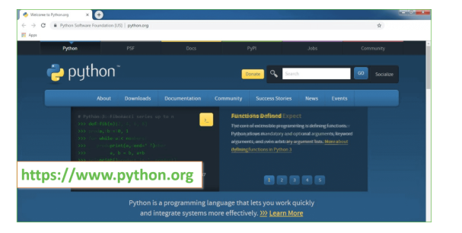
Now, check for the latest and the correct version for your operating system.
Step 2: Click on the Download Tab.

Step 3: You can either select the Download Python for windows 3.7.4 button in Yellow Color or you can scroll further down and click on download with respective to their version. Here, we are downloading the most recent python version for windows 3.7.4
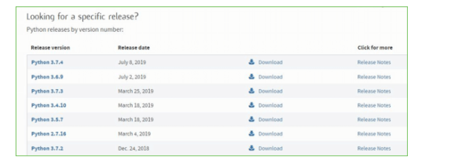
Step 4: Scroll down the page until you find the Files option.

Step 5: Here you see a different version of python along with the operating system.

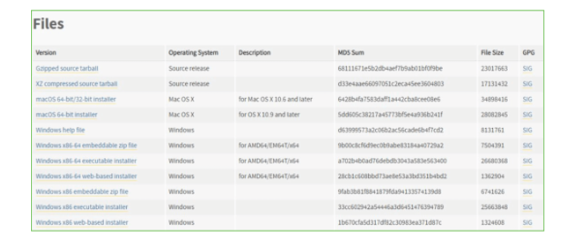

• To download Windows 32-bit python, you can select any one from the three options: Windows x86 embeddable zip file, Windows x86 executable installer or Windows x86 web-based installer.
•To download Windows 64-bit python, you can select any one from the three options: Windows x86-64 embeddable zip file, Windows x86-64 executable installer or Windows x86-64 web-based installer.
Here we will install Windows x86-64 web-based installer. Here your first part regarding which version of python is to be downloaded is completed. Now we move ahead with the second part in installing python i.e. Installation
Note: To know the changes or updates that are made in the version you can click on the Release Note Option.

Installation of Python
Step 1: Go to Download and Open the downloaded python version to carry out the installation process.
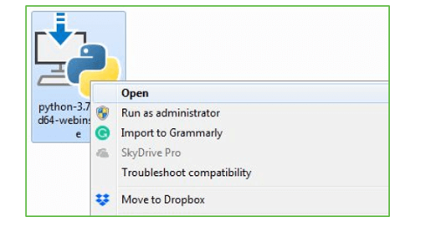
Step 2: Before you click on Install Now, Make sure to put a tick on Add Python 3.7 to PATH.

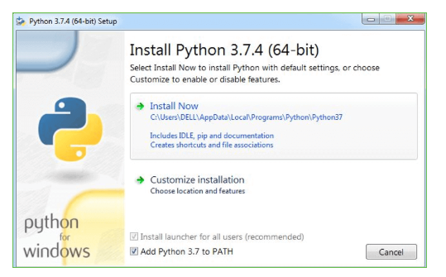

Step 3: Click on Install NOW After the installation is successful. Click on Close.

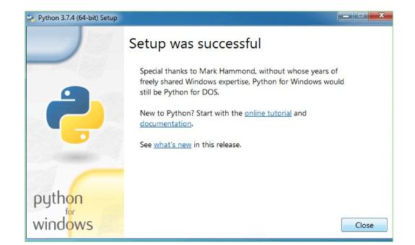

With these above three steps on python installation, you have successfully and correctly installed Python. Now is the time to verify the installation.
Note: The installation process might take a couple of minutes.

Verify the Python Installation
Step 1: Click on Start
Step 2: In the Windows Run Command, type “cmd”.

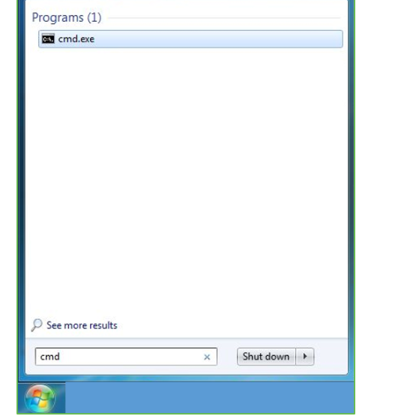
Step 3: Open the Command prompt option.
Step 4: Let us test whether the python is correctly installed. Type python –V and press Enter.

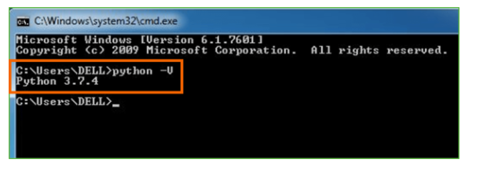
Step 5: You will get the answer as 3.7.4
Note: If you have any of the earlier versions of Python already installed. You must first uninstall the earlier version and then install the new one.

Check how the Python IDLE works
Step 1: Click on Start
Step 2: In the Windows Run command, type “python idle”.
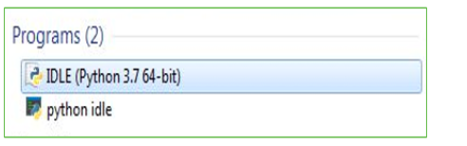
Step 3: Click on IDLE (Python 3.7 64-bit) and launch the program
Step 4: To go ahead with working in IDLE you must first save the file. Click on File > Click on Save

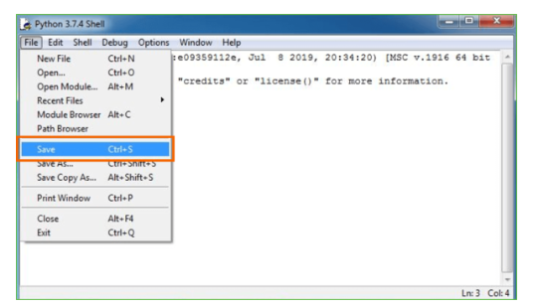
Step 5: Name the file and save as type should be Python files. Click on SAVE. Here I have named the files as Hey World.
Step 6: Now for e.g. enter print

6. MODULES AND METHODOLOGY
6.1 TECHNOLOGY USED:
Programming Language:
Python: Python is widely used in the field of data science and network security. It offers extensive libraries for data processing, machine learning, and network analysis.
Libraries and Frameworks:
NumPy and pandas: For numerical computations and data manipulation.
scikit-learn: For implementing machine learning models and algorithms.
TensorFlow or PyTorch: For deep learning-based approaches, if needed.
NetworkX: For network analysis and graph algorithms.
Scapy: For packet manipulation and network traffic analysis.
Matplotlib and Seaborn: For data visualization.
Flask or Django: For building a web-based user interface or API endpoints for integration.
Development Environment:
Jupyter Notebook or JupyterLab: For interactive development and experimentation.
Integrated Development Environment (IDE): Options like PyCharm, Visual Studio Code, or Atom can be used for writing, debugging, and managing code.
Version Control:
Git: For version control and collaboration.
Infrastructure and Deployment:
Docker: For containerization of the application components, ensuring consistency across different environments.
Kubernetes: For orchestration and management of containerized applications, if deploying at scale.
Cloud Platforms: Such as AWS, Google Cloud, or Azure, for deploying and scaling the application in the cloud.
Monitoring and Logging:
ELK Stack (Elasticsearch, Logstash, Kibana): For centralized logging, monitoring, and visualization of system logs and metrics.
Prometheus and Grafana: For time-series monitoring and visualization.
Security and Compliance:
SSL/TLS: For securing network communication.
OWASP ModSecurity Core Rule Set: For web application firewall rules.
Security Information and Event Management (SIEM): For real-time analysis of security alerts and events.
Documentation and Collaboration:
Jira, Confluence, or Asana: For project management and documentation.
Slack or Microsoft Teams: For team communication and collaboration.
6.2 LIST OF MODULES:
Tensorflow
TensorFlow is a free and open-source software library for dataflow and differentiable programming across a range of tasks. It is a symbolic math library, and is also used for machine learning applications such as neural networks. It is used for both research and production at Google.‍
TensorFlow was developed by the Google Brain team for internal Google use. It was released under the Apache 2.0 open-source license on November 9, 2015.
Numpy
Numpy is a general-purpose array-processing package. It provides a high-performance multidimensional array object, and tools for working with these arrays.
It is the fundamental package for scientific computing with Python. It contains various features including these important ones:
- A powerful N-dimensional array object
- Sophisticated (broadcasting) functions
- Tools for integrating C/C++ and Fortran code
- Useful linear algebra, Fourier transform, and random number capabilities
Besides its obvious scientific uses, Numpy can also be used as an efficient multi-dimensional container of generic data. Arbitrary data-types can be defined using Numpy which allows Numpy to seamlessly and speedily integrate with a wide variety of databases.
Pandas
Pandas is an open-source Python Library providing high-performance data manipulation and analysis tool using its powerful data structures. Python was majorly used for data munging and preparation. It had very little contribution towards data analysis. Pandas solved this problem. Using Pandas, we can accomplish five typical steps in the processing and analysis of data, regardless of the origin of data load, prepare, manipulate, model, and analyze. Python with Pandas is used in a wide range of fields including academic and commercial domains including finance, economics, Statistics, analytics, etc.
Matplotlib
Matplotlib is a Python 2D plotting library which produces publication quality figures in a variety of hardcopy formats and interactive environments across platforms. Matplotlib can be used in Python scripts, the Python and IPython shells, the Jupyter Notebook, web application servers, and four graphical user interface toolkits. Matplotlib tries to make easy things easy and hard things possible. You can generate plots, histograms, power spectra, bar charts, error charts, scatter plots, etc., with just a few lines of code. For examples, see the sample plots and thumbnail gallery.
For simple plotting the pyplot module provides a MATLAB-like interface, particularly when combined with IPython. For the power user, you have full control of line styles, font properties, axes properties, etc, via an object-soriented interface or via a set of functions familiar to MATLAB users.
Scikit – learn
Scikit-learn provides a range of supervised and unsupervised learning algorithms via a consistent interface in Python. It is licensed under a permissive simplified BSD license and is distributed under many Linux distributions, encouraging academic and commercial use.
6.3 METHODOLOGY:
Data Collection
The first step involves collecting network traffic data from publicly available DDoS datasets and real-time cloud environments. The data includes parameters such as source IP, destination IP, port numbers, protocol types, packet rates, and flow duration.
Since cloud environments generate huge amounts of data every second, this stage is designed to handle Big Data effectively. To achieve this, the MapReduce framework is used for distributed data processing, which helps in handling massive datasets in parallel and reduces processing time.
The goal of this phase is to gather a diverse and representative dataset that includes both normal and malicious traffic samples to train and evaluate the detection model.
Data Preprocessing
After collecting the data, the next step is preprocessing to improve its quality and make it suitable for analysis. The raw data may contain missing values, duplicate entries, or inconsistent formats. Preprocessing includes:
- Data Cleaning: Removing noise, redundant, or incomplete data.
- Data Normalization: Scaling numerical values to a consistent range for better model performance.
- Data Transformation: Converting categorical attributes into numerical formats suitable for machine learning algorithms.
This ensures the dataset is clean, accurate, and ready for further processing.
Feature Extraction
In this phase, key network characteristics are extracted that can help differentiate between normal and attack traffic. Features such as packet count, average flow duration, inter-arrival time, and traffic rate are derived.
The Mapper function of the MapReduce framework is used to perform this task efficiently over large datasets. These extracted features represent the behavioral patterns of network flows and form the basis for detecting potential DDoS attacks.
Feature Selection
Not all extracted features contribute equally to attack detection. Hence, feature selection is performed using the Recursive Feature Elimination (RFE) method. RFE helps to identify and retain only the most significant features that have the highest impact on the classification performance.
This step reduces the model’s complexity, enhances speed, and improves the detection accuracy by removing irrelevant or redundant features.
Model Development
A hybrid deep learning model combining Long Short-Term Memory (LSTM) and Deep Maxout (DMO) networks is developed.
- The LSTM network captures time-based dependencies and sequential patterns in network traffic, making it effective for detecting ongoing or time-dependent attacks.
- The DMO network enhances non-linear representation learning, improving the model’s ability to classify complex network behaviors.
Together, they create a robust hybrid framework capable of accurate and adaptive DDoS detection.
Model Optimization
To further refine model performance, the White Shark–Remora Optimization Algorithm (WSROA) is applied. This bio-inspired optimization algorithm fine-tunes the weights and learning parameters of the hybrid model, ensuring faster convergence and higher detection precision.
Training and Testing
The dataset is divided into training (80%) and testing (20%) subsets. The training phase allows the hybrid model to learn normal and malicious traffic behaviors, while the testing phase evaluates the model’s performance using metrics like accuracy, precision, recall, andF1-score.
This ensures that the proposed model is reliable, efficient, and capable of generalizing to unseen data.
Attack Detection and Classification
Once trained, the hybrid model is deployed to monitor real-time cloud traffic. It analyzes incoming data flows and classifies them as either normal or DDoS attack traffic. Detected attacks are immediately flagged, allowing administrators to take preventive or corrective actions to maintain service availability and protect cloud infrastructure.
Continuous Learning
To keep up with evolving attack patterns, the system is designed to continuously learn from new traffic data. The model is periodically retrained with updated datasets to ensure it adapts to new attack behaviours and maintains high detection accuracy over time
MATPLOTLIB
Matplotlib is a Python 2D plotting library which produces publication quality figures in a variety of hardcopy formats and interactive environments across platforms. Matplotlib can be used in Python scripts, the Python and IPython shells, the Jupyter notebook, web application servers, and four graphical user interface toolkits. It provides a variety of functions to visualize data and create static, animated, and interactive plots. Matplotlib is widely used for tasks ranging from simple line plots to complex visualizations.
6.4 DATA VISUALIZATION TECHNIQUES:
- Bar Graph
- Pie Chart
- Box Plot
- Histogram
- Line Chart and Subplots
- Scatter Plot

BAR GRAPH
Bar graphs are best used when we need to compare the quantity of categorical values within the same category. Bar graphs should not be used for continuous values.
Bar graph is generated using plt.bar() in matplotlib
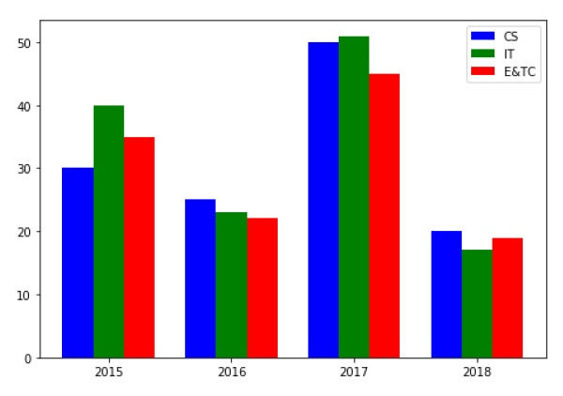
Figure 6.4.1 Bar Graph
3.12 PIE CHART USING MATPLOTLIB
A pie chart is suitable to show the proportional distribution of items within the same category.plt.pie() is used to draw the pie chart and adjust its parameters to make it more appealing.
A pie chart is rendered useless when there are a lot of items within a category. This will decrease the size of each slice and there will be no distinction between the items.
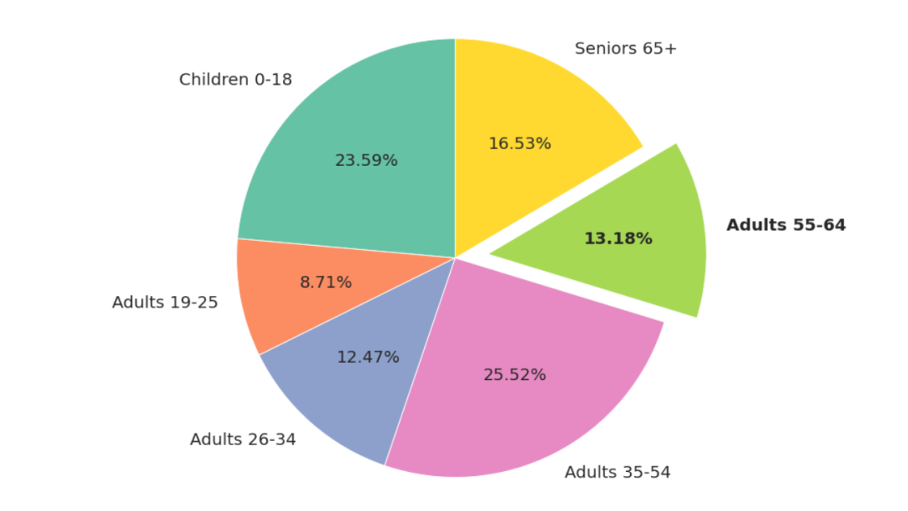
Figure 6.4.2 Pie Chart
3.12 BOX PLOT USING MATPLOTLIB
Box plot gives statistical information about the distribution of numeric data divided into different groups. It is useful for detecting outliers within each group. The lower, middle and upper part of the box represents the 25th, 50th, and 75th percentile values respectively. Box plot does not show the distribution of data points within each group.
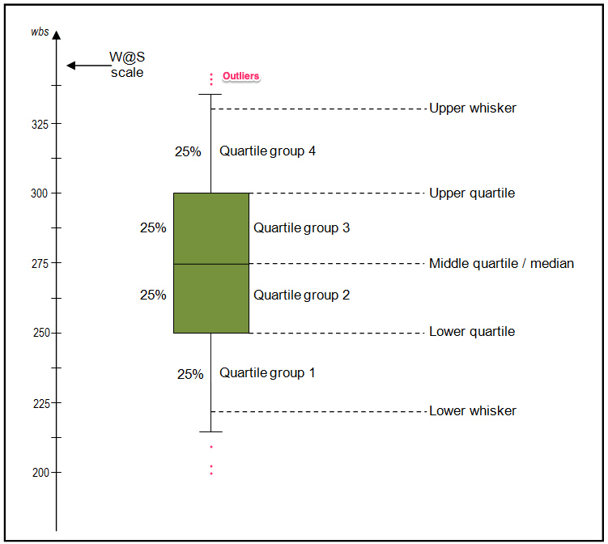
Figure 6.4.3 Box Plot
3.13 HISTOGRAM USING MATPLOTLIB
A histogram shows the distribution of numeric data through a continuous interval by segmenting data into different bins. Useful for inspecting skewness in the data. It is easy to confuse histograms with bar plots. But remember, histograms are used with continuous data whereas bar plots are used with categorical data.
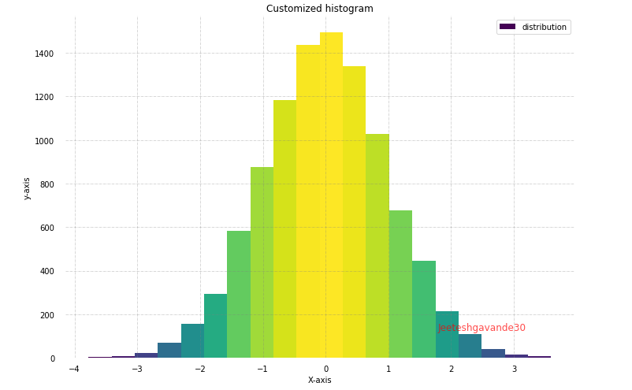
Figure 6.4.4 Histogram
3.14 LINE PLOT AND SUBPLOTS USING MATPLOTLIB
A line plot is useful for visualizing the trend in a numerical value over a continuous time interval. Matplotlib subplots makes it easy to view and compare different plots in the same figure. The plt.subplots() figure returns the figure and axes. You can provide as an input to the function how you want to display the axes within the figure. These will be adjusted using the nrows and ncols parameters. You can even adjust the size of the figure using the figsize parameter.

Figure 6.4.5 Subplot
3.9 SCATTER PLOT USING MATPLOTLIB
Scatter plots are useful for showing the relationship between two variables. Any correlation between variables or outliers in the data can be easily spotted using scatter plots.
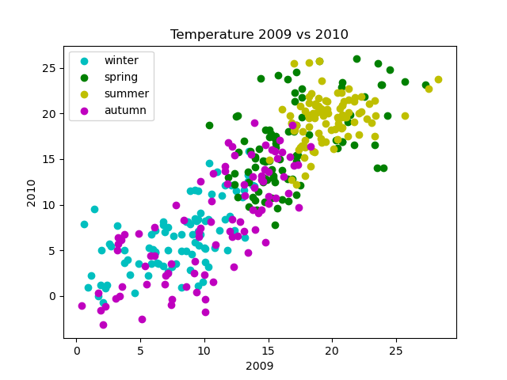
Figure 6.4.6 Scatter Plot
3.10 SEABORN
Seaborn is a statistical data visualization library based on Matplotlib. Seaborn is a powerful and flexible data visualization library in Python that offers an easy-to-use interface for creating informative and aesthetically pleasing statistical graphics. It provides a range of tools for visualizing data, including advanced statistical analysis, and makes it easy to create complex multi-plot visualizations Seaborn's key benefit lies in its capability to generate attractive plots with minimal coding efforts. It provides a range of default themes and color palettes, which you can easily customize to suit your preferences. Additionally, Seaborn offers a range of built-in statistical functions, allowing users to easily perform complex statistical analysis with their visualizations. Another notable feature of Seaborn is its ability to create complex multi-plot visualizations. With Seaborn, users can create grids of plots that allow for easy comparison between multiple variables or subsets of data. This makes it an ideal tool for exploratory data analysis and presentation.
3.11 PLOT TYPES IN SEABORN
- LINE PLOT: Line plots are used to visualize trends in data over time or other continuous variables. In a line plot, each data point is connected by a line, creating a smooth curve. In Seaborn, line plots can be created using the lineplot() function.
- HISTOGRAM: Histograms visualize the distribution of a continuous variable. In a histogram, the data is divided into bins and the height of each bin represents the frequency or count of data points within that bin. In Seaborn, histograms can be created using the histplot() function.
- BOX PLOT: Box plots are a type of visualization that shows the distribution of a dataset. They are commonly used to compare the distribution of one or more variables across different categories.
- VIOLIN PLOT: A violin plot is a type of data visualization that combines aspects of both box plots and density plots. It displays a density estimate of the data, usually smoothed by a kernel density estimator, along with the interquartile range (IQR) and median in a box plot-like form. The width of the violin represents the density estimate, with wider parts indicating higher density, and the IQR and median are shown as a white dot and line within the violin.

Figure 6.4.7. Violin Plot
- HEATMAP. A heatmap is a graphical representation of data that uses colors to depict the value of a variable in a two-dimensional space. Heatmaps are commonly used to visualize the correlation between different variables in a dataset.

Figure 6.4.8 Heat Map
- PAIRPLOT: Pair plots are a type of visualization in which multiple pairwise scatter plots are displayed in a matrix format. Each scatter plot shows the relationship between two variables, while the diagonal plots show the distribution of the individual variables.
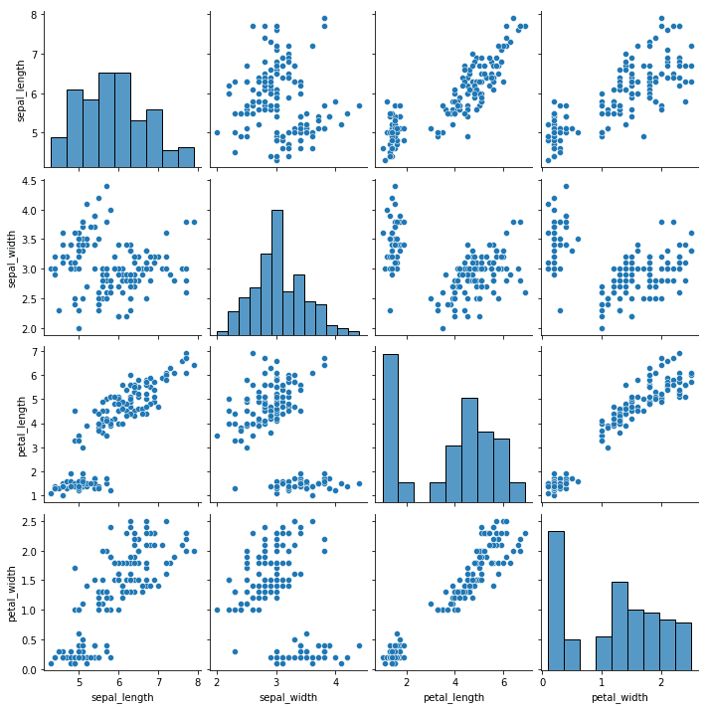
Figure 6.4.9 Pair Plot
6.5 SYSTEM ARCHITECTURE:
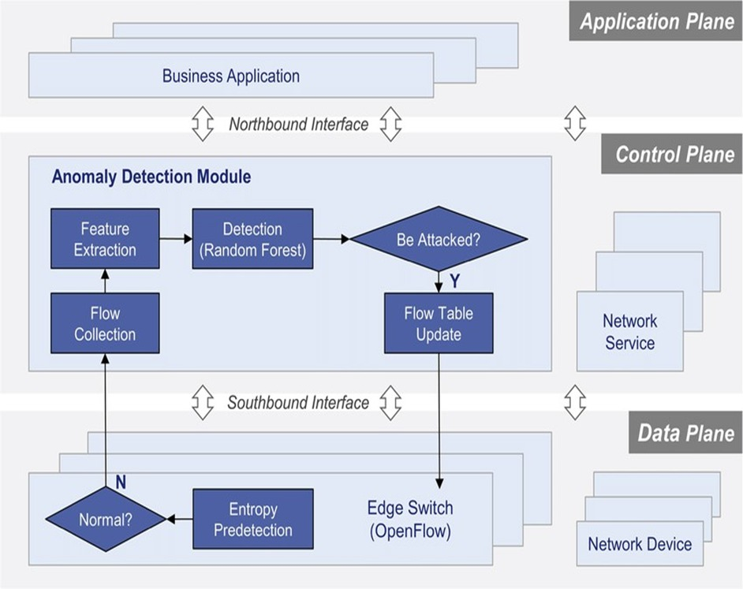
Figure 6.5 System Architecture
6.6 CODE:
Certainly, implementing a complete DDoS attack detection system using entropy-based approaches requires a significant amount of code and infrastructure. However, I can provide you with a basic example of how you might calculate entropy from network traffic data using Python. This example assumes you have access to network traffic data in some form.

python
Copy code
import numpy as np
def calculate_entropy(data):
unique_elements, counts_elements = np.unique(data, return_counts=True)
probabilities = counts_elements / len(data)
entropy = -np.sum(probabilities * np.log2(probabilities))
return entropy
# Example network traffic data (packet sizes in bytes)
network_traffic = [100, 150, 200, 100, 100, 150, 200, 150, 100, 100]
# Calculate entropy of packet sizes
entropy = calculate_entropy(network_traffic)
print("Entropy of network traffic:", entropy)
In this example, we define a function calculate-entropy that takes in a list of data and computes its entropy based on the probabilities of each unique element. We then apply this function to a sample of network traffic data (represented by packet sizes in bytes) to calculate the entropy.
Please note that this is a simplified example and does not include the entire process of DDoS attack detection, including data preprocessing, anomaly detection, and alerting mechanisms. Also, real-world DDoS detection systems may require more sophisticated algorithms and integration with network infrastructure.
For a comprehensive DDoS detection system, you would need to incorporate additional components such as data collection, preprocessing, anomaly detection algorithms (e.g., machine learning models), integration with network infrastructure, and alerting mechanisms. Additionally, consider using specialized libraries and tools tailored for network security tasks.
6.7 IMPLEMENTATION:
Data Collection:
Set up data collection mechanisms to gather network traffic data from various sources, such as routers, switches, or network taps.
Ensure that the data collected is in a format suitable for analysis and includes relevant information like packet headers and flow records.
Preprocessing:
Preprocess the raw network traffic data to filter out noise and extract relevant features for entropy analysis.
Normalize the data to handle variations in packet sizes and traffic volumes.

Entropy Calculation:
Implement algorithms to calculate entropy measures, such as packet entropy, flow entropy, or information entropy, from the pre-processed data.
Determine suitable parameters for entropy calculation, such as the size of data windows or time intervals.
Anomaly Detection:
Develop machine learning models or statistical methods to detect anomalous behaviour in network traffic based on entropy measures.
Train the models using labelled data to distinguish between normal and malicious traffic patterns.
Define thresholds for abnormal entropy levels to trigger alerts for potential DDoS attacks.
Alerting and Reporting:
Set up alerting mechanisms to notify system administrators or security personnel when suspicious activity indicative of a DDoS attack is detected.
Provide detailed reports on detected attacks, including information about the type of attack, affected resources, and severity level.
Integration and Deployment:
Integrate the detection system with existing network infrastructure and security tools, such as firewalls, intrusion detection systems, or SIEM platforms.
Deploy the system in production environments, ensuring compatibility with the network architecture and scalability to handle large volumes of traffic.
Testing and Validation:
Conduct thorough testing and validation of the detection system to ensure its accuracy, reliability, and performance under different conditions.
Use simulated DDoS attacks or historical attack data to evaluate the effectiveness of the system in detecting and mitigating threats.
Monitoring and Maintenance:
Establish continuous monitoring of the detection system to monitor its performance and detect any anomalies or deviations from expected behaviour.
Implement mechanisms for periodic maintenance, updates, and optimization to improve the system's effectiveness over time.
Provide training and documentation for system administrators and security analysts on using and managing the detection system effectively.
Feedback and Iteration:
Gather feedback from system users and stakeholders to identify areas for improvement or refinement in the detection system.
Iterate on the design and implementation based on feedback and lessons learned from real-world deployment and operation.
Compliance and Security:
Ensure compliance with relevant regulatory requirements and industry standards for network security and data privacy, such as GDPR or PCI DSS.
Implement security measures to protect the detection system against unauthorized access, tampering, or exploitation by attackers.

- ALGORITHMS
7.1 DEEP LEARNING:
Deep learning (DL) projects for DDoS detection in cloud computing typically employ hybrid architectures and meta-heuristic optimization strategies to handle high-dimensional, imbalanced network traffic.
7.2 CONVOLUTIONAL NEURAL NETWORK:
Excellent for identifying local spatial patterns in network traffic features. They are often optimized by substituting fully connected layers with Global Average Pooling (GAP) to reduce parameters and prevent overfitting.
7.3 RANDOM FOREST:
This methodology includes a huge volume of Trees of individual choice acting as an ensembling model. Every tree of choice in the random forest churns out a group forecasting and the group with the majority votes turns out the forecasting of the framework. The core idea behind this methodology is collective wisdom, a plain yet strong one. The rationale that this methodology paradigm performs so well in data science as any of the behaviours of individual models will be surpassed by a huge volume of relatively uncorrelated frameworks working as a committee. The main aspect is the low association between the frameworks. When low-correlation portfolios (such as stocks and bonds) come together to construct unrelated frameworks may provide ensemble forecasts that are more trustworthy than any one of the many projections for a portfolio that is higher than the total of its parts. This magnificent effect has been explained by the trees defending each other (as long as they do not all err in the same direction) from their mistakes. While some trees are wrong, numerous other trees are accurate, since they travel as a cluster in the proper direction.
7.4 SUPPORT VECTOR MACHINE(SVM):
The major aim of this methodology is to determine a hyperplane that separates into various groups in a space that consists of N attributes. Various possible hyperplanes can be chosen to differentiate between the two information point groupings. The major aim of this methodology is to determine a plane that has the highest margin, i.e. the maximum gap among all data points that belong to various classes. Enhancing the width disparity provides some assistance in classifying additional trust into possible information items. The data points belonging to various classes will be separated with the aid of decision boundaries which are nothing but hyperplanes. The number of features decides the dimension of the hyperplane. The data points nearer to the hyperplane and those points that can impact the position, as well as the hyperplane alignment, is termed vectors of support. These support vectors play a vital role in maximizing the gap among the various classifiers. These support vectors are helpful in building an SVM-based model.
7.5 LONG SHORT-TERM MEMORY NETWORK:
Sequence processing of input neural network types includes recurrent neural networks. Previously predicted amounts can use as inputs because of hidden states. A multilayer perceptron is an RNN. It has been through a pattern. Input, output, and a hidden layer serve as its framework. A multilayered perceptron's n layers are chosen by the order in which they are generated. The deep learning algorithm was developed using the assistance of the Keras software platform. A structure must be maintained as data enters, is retained by the algorithm, and accesses pointless use of three gates: an input gate, a memory gate, and an output gate. The three of these gates, which constitute most of the model known as LSTM.
7.6 RADIAL BASIS FUNCTION(RBF)NEURAL NETWORK:
Radial Basis Function within a feed-forward neural network model with exceptional performance and global approximation. RBF has three layers: an input layer, a hidden layer, and an output layer. A node known as RBF units, which is a node representing a Gaussian function, may be found in the hidden layer. The localization function centre and width of an RBF neural network are determined by two essential factors. The order of appearance of the data points inside the input area may not be equal when the centre and width of the RBF neurons are chosen at random. A typical RBF neural network is a locally weighted network that emphasizes certain portions of the training data set. In training, the hidden layer's "base" is RBF, and the input vector is moved immediately to the hidden space. A proportional weighted average of the hidden unit's output represents what an RBF artificial neural network generates for its output.
7.7 HYBRID MODEL:
Creating a hybrid model that combines an LSTM (Long Short-Term Memory) network and a Radial Basis Function Neural Network (RBFNN) is an interesting idea. The basic idea is to use the LSTM to process sequential data and capture temporal dependencies, while the RBFNN can handle the non-linear relationships and interpolate between data points.

8. SYSTEM DESIGN
Architect a system capable of capturing and analyzing network traffic in real-time.
Implement algorithms for calculating entropy measures from network data streams.
Integrate machine learning models for anomaly detection and classification of DDoS attacks.
Design a user interface for monitoring and managing the detection system, including alert notifications and reporting functionalities.
Implementation:
Develop software modules for data collection, preprocessing, and entropy analysis.
Implement machine learning algorithms for training and deploying detection models.
Integrate the system with existing network infrastructure and security tools.
Conduct extensive testing and validation to ensure the accuracy and reliability of the detection system.
Deployment:
Deploy the detection system in production environments, considering factors like network topology and traffic patterns.
Configure system parameters and thresholds based on the specific requirements of the network.
Provide training and documentation for system administrators and security personnel on using and managing the detection system effectively.
Monitoring and Maintenance:
Establish continuous monitoring of the detection system to ensure optimal performance.
Monitor system logs and alerts for any anomalies or performance degradation.
Regularly update the system with new threat intelligence and mitigation strategies to adapt to evolving DDoS attack techniques.
Perform periodic maintenance and optimization to improve the efficiency and effectiveness of the detection system over time.
Evaluation:
Evaluate the performance of the detection system in detecting DDoS attacks compared to traditional methods.
Measure metrics such as detection accuracy, false positive rates, and response time.
Gather feedback from system users and stakeholders to identify areas for improvement and refinement.
Iterate on the design and implementation based on evaluation results to enhance the overall efficacy of the detection system.

8.1 UML DIAGRAMS:
CLASS DIAGRAM:
The class diagram is used to refine the use case diagram and define a detailed design of the system. The class diagram classifies the actors defined in the use case diagram into a set of interrelated classes. The relationship or association between the classes can be either an "is-a" or "has-a" relationship. Each class in the class diagram may be capable of providing certain functionalities. These functionalities provided by the class are termed "methods" of the class. Apart from this, each class may have certain "attributes" that uniquely.

Figure 8.1.1 Class Diagram
USE CASE DIAGRAM:
A use case diagram in the Unified Modelling Language (UML) is a type of behavioural diagram defined by and created from a Use-case analysis. Its purpose is to present a graphical overview of the functionality provided by a system in terms of actors, their goals (represented as use cases), and any dependencies between those use cases. The main purpose of a use case diagram is to show what system functions are performed for which actor. Roles of the actors in the system can be depicted.

Figure 8.1.2 Use Case Diagram
SEQUENCE DIAGRAM:
A sequence diagram represents the interaction between different objects in the system. The important aspect of a sequence diagram is that it is time-ordered. This means that the exact sequence of the interactions between the objects is represented step by step. Different objects in the sequence diagram interact with each other by passing "messages".

Figure 8.1.3 Sequence Diagram
COLLABORATIVE DIAGRAM:
A collaboration diagram groups together the interactions between different objects. The interactions are listed as numbered interactions that help to trace the sequence of the interactions. The collaboration diagram helps to identify all the possible interactions that each object has with other objects.
Figure 8.1.4 Collaborative Diagram
9. RESULTS AND DISCUSSIONS
9.1 DATASET SCREENSHOTS:
In computer world two systems can interact with each other using network connection and sometime some malicious users can intercept those connections signals and then alter request values to perform malicious activities on receiver system. To detect and avoid such malicious attacks we are employing CUSUM entropy based DDOS (distributed denial of service) attacks detection technique.
The cumulative sum of entropy (CUSUM) can be used to track the randomness of the data over time. For example, if the cumulative sum of entropy is increasing, then the data is becoming more random. If the cumulative sum of entropy is decreasing, then the data is becoming less random.
As per CUSUM technique if there is sudden change in value then it will consider as attack. While normal communication all system network signature CUSUM value will be less than 0 and if malicious alteration occur then CUSUM value will get high and based on this approach we can say weather network communication is normal or attack.
To train CUSUM algorithm we are employing DDOS dataset and below screen showing dataset details

Figure 9.1.1 dataset
In above dataset screen first row represents dataset column names of network connection and remaining rows represents values and in last column we have class label as 0 or 1 where 0 means normal and 1 means attack. We will use this label to compare CUSUM prediction is correct or not and based on this we will evaluate its performance using Accuracy, Precision, Recall and FSCORE.
In below screen showing code for CUSUM computation
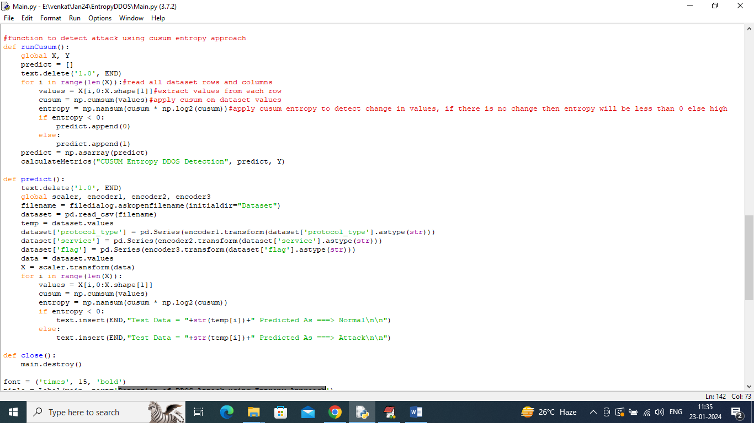
Figure 9.1.2 Entropy Based attack detection
In above screen read red colour comments to know about entropy-based attack detection.
To implement this project, we have designed following modules
- Upload DDOS Dataset: using this module we will upload dataset to application and then plot graph of number of normal and attacks records
- Pre-process Dataset: dataset contains both numeric and non-numeric values but CUSUM will accept only numeric values so will process dataset to convert non-numeric values to numeric values and then shuffle and replace missing values with 0
- Normalize Training Features: using this module we will normalize all processed dataset values
- Train CUSUM Entropy Model: using this module will compute CUSUM entropy technique to detect attacks packets and then compare predicted labels with actual labels to calculate accuracy
- Predict Attack from Test Data: using this module we will upload test data and then apply CUSUM entropy model to predict weather test data is normal or attack.

9.2 RESULT SCREENSHOTS:
To run project double click on ‘run.bat’ file to get below screen
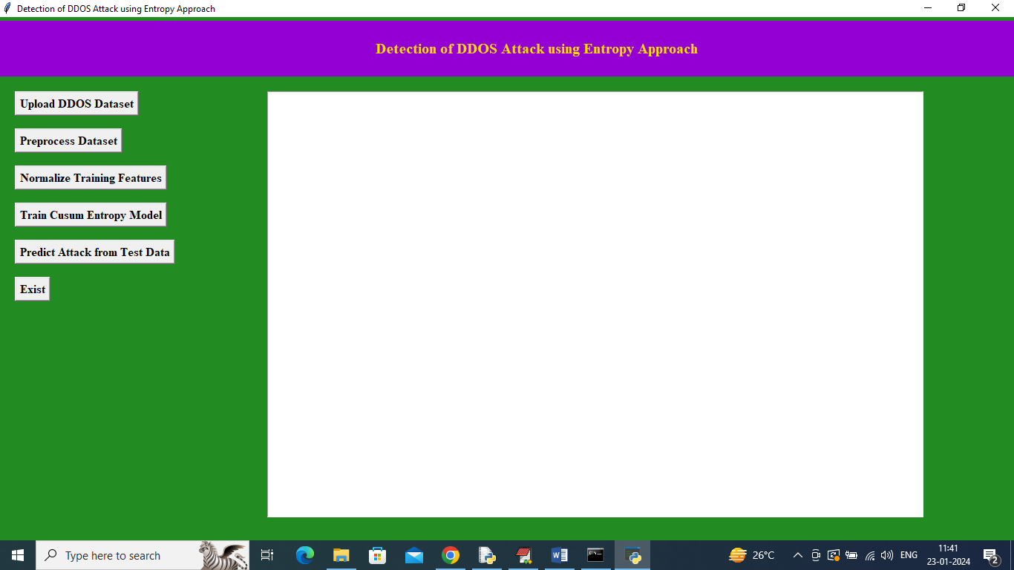
Figure 9.2.1 Output Interface
In above screen click on ‘Upload DDOS Dataset’ button to upload dataset and then will get below output
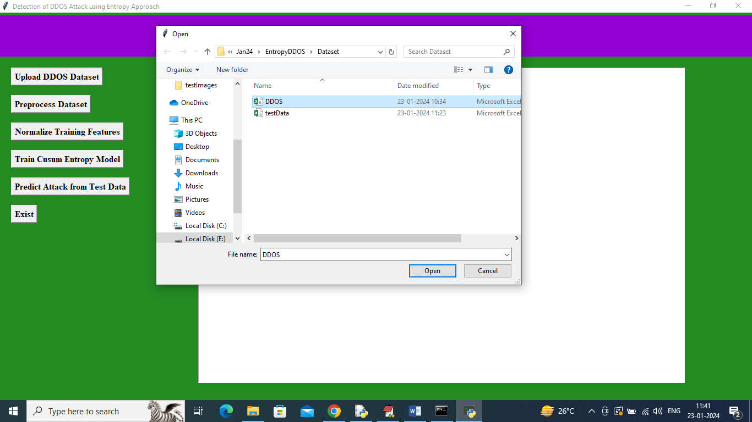
Figure 9.2.2 Dataset Upload
In above screen selecting and uploading ‘DDOS’ dataset file and then click on ‘Open’ button to load dataset and then will get below output
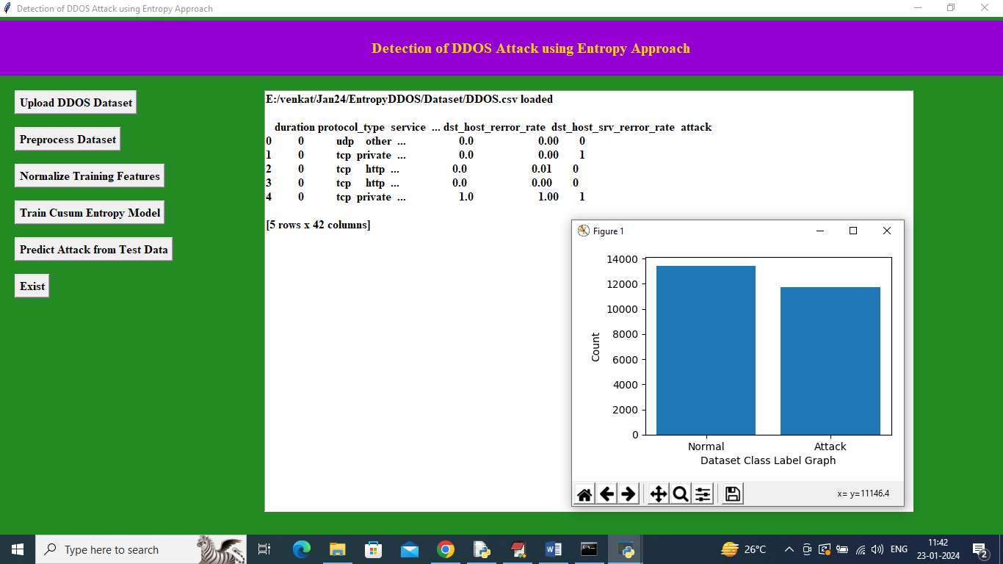
Figure 9.2.3 Dataset Loaded
In above screen dataset loaded and displaying few records from dataset and can see dataset contains both numeric and non-numeric values and by processing dataset will convert non-numeric to numeric values. In above graph x-axis represents class labels and y-axis represents number of records in that class label. Now close above graph and then click on ‘Pre-process Dataset’ button to process dataset and then will get below output
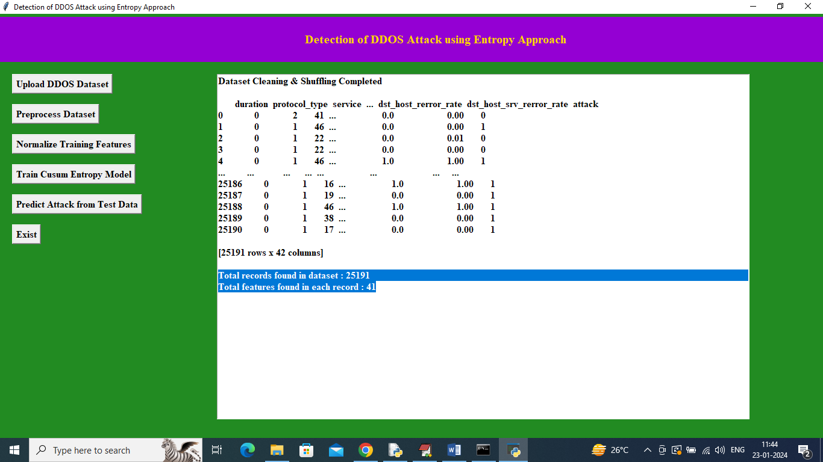
Figure 9.2.4 Dataset Values
In above screen can see all dataset values converted to numeric and can see total records and number of features available in each record and now click on ‘Normalize Training Features’ button to get below output
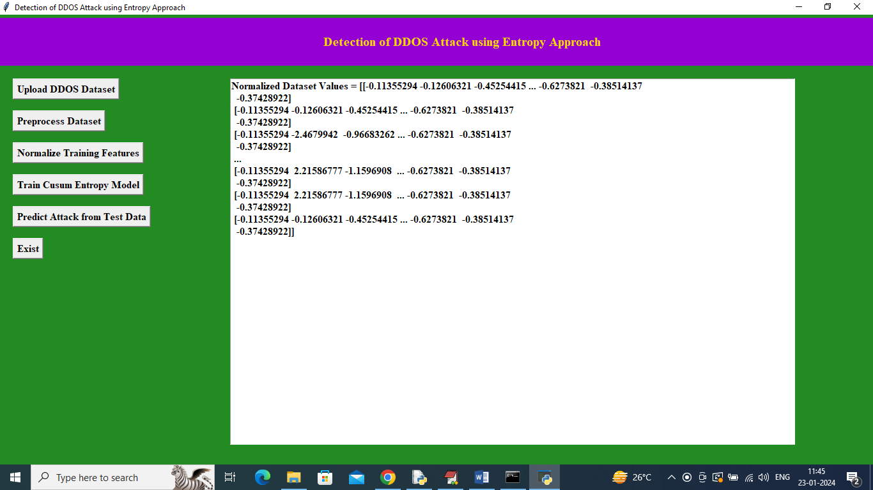
Figure 9.2.5 Dataset Values Normalize
In above screen all dataset values normalized and now click on ‘Train CUSUM Entropy Model’ button to train entropy and get below output
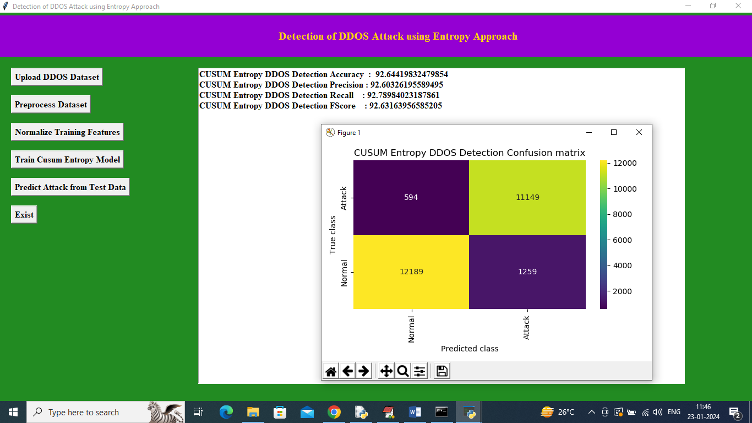
Figure 9.2.6 DDOS attack detection
In above screen entropy DDOS attack detection got 92% accuracy and can see other metrics also and in confusion matrix graph x-axis represents Predicted Labels and y-axis represents True Labels and all yellow and light green boxes contains correct prediction count and all blue boxes contains incorrect prediction count which are very few. Now close above graph and then click on ‘Predict Attack from Test Data’ button to upload test data and then will get below output
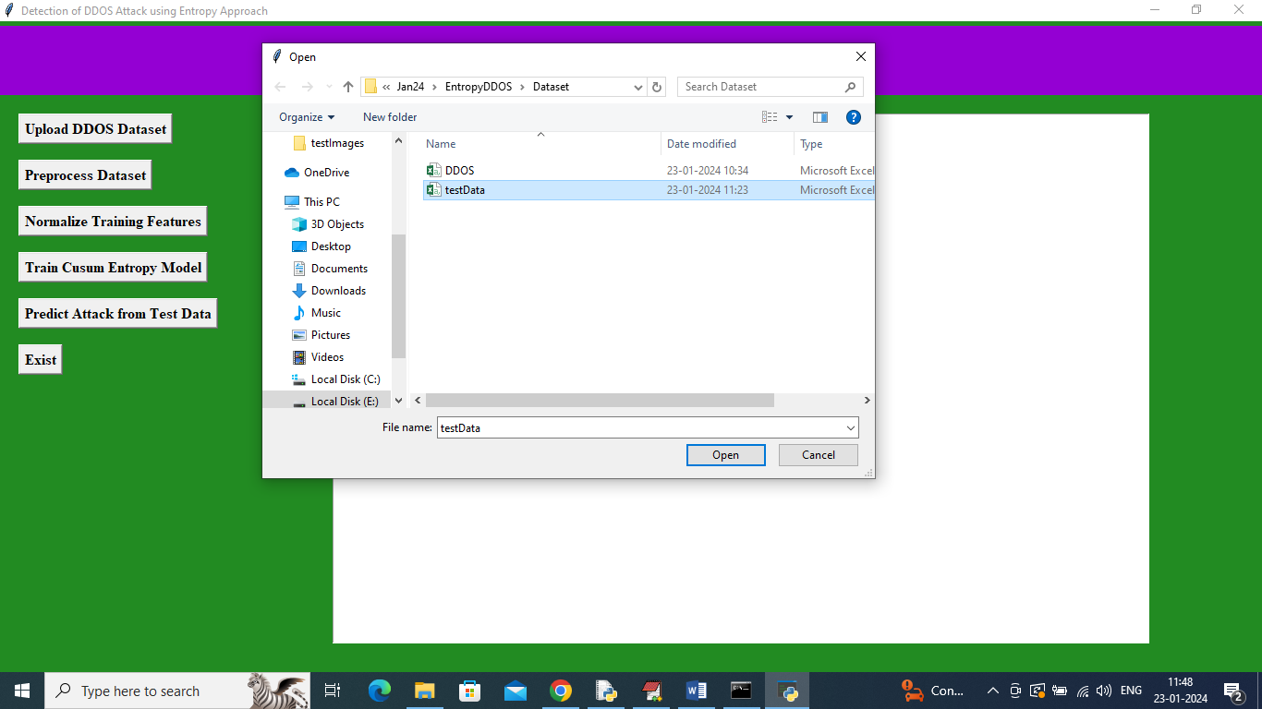
Figure 9.2.7 Test Data
In above screen selecting and uploading ‘test data’ file and then click on ‘Open’ button to get below output

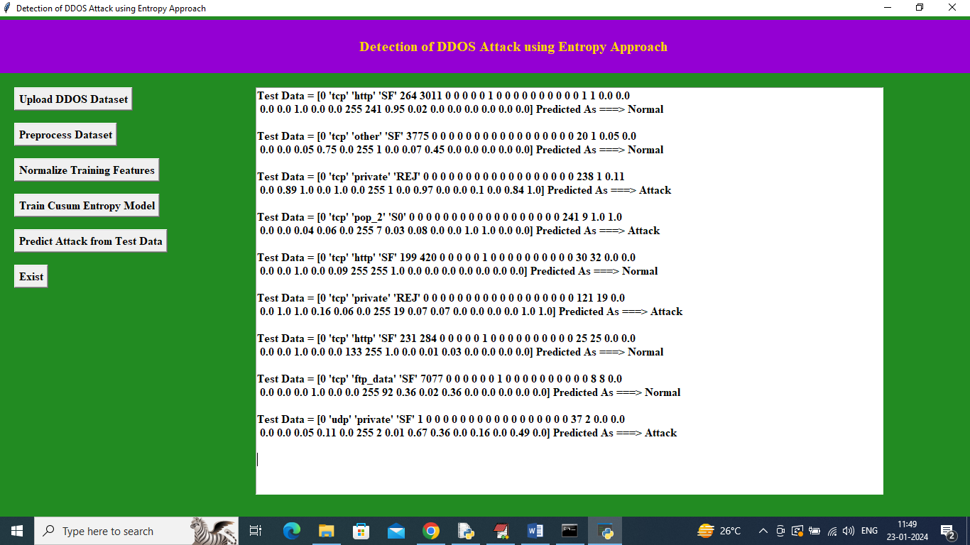
Figure 9.2.8 Test Data Values
In above screen in square bracket can see TEST DATA values and after = arrow symbol can see CUSUM predicted values as ‘Normal or Attack’

10. TESTING AND VALIDATION
10.1 SYSTEM TEST:
The purpose of testing is to discover errors. Testing is the process of trying to discover every conceivable fault or weakness in a work product. It provides a way to check the functionality of components, sub-assemblies, assemblies and/or a finished product It is the process of exercising software with the intent of ensuring that the Software system meets its requirements and user expectations and does not fail in an unacceptable manner. There are various types of tests. Each test type addresses a specific testing requirement.

10.2 TYPES OF TESTS:

Unit testing
Unit testing involves the design of test cases that validate that the internal program logic is functioning properly, and that program inputs produce valid outputs. All decision branches and internal code flow should be validated. It is the testing of individual software units of the application .it is done after the completion of an individual unit before integration. This is a structural testing, that relies on knowledge of its construction and is invasive. Unit tests perform basic tests at component level and test a specific business process, application, and/or system configuration. Unit tests ensure that each unique path of a business process performs accurately to the documented specifications and contains clearly defined inputs and expected results.

Integration testing
Integration tests are designed to test integrated software components to determine if they actually run as one program. Testing is event driven and is more concerned with the basic outcome of screens or fields. Integration tests demonstrate that although the components were individually satisfaction, as shown by successfully unit testing, the combination of components is correct and consistent. Integration testing is specifically aimed at exposing the problems that arise from the combination of components.

Functional test

Functional tests provide systematic demonstrations that functions tested are available as specified by the business and technical requirements, system documentation, and user manuals.
Functional testing is centred on the following items:
Valid Input : identified classes of valid input must be accepted.
Invalid Input : identified classes of invalid input must be rejected.
Functions : identified functions must be exercised.
Output : identified classes of application outputs must be exercised.
Systems/Procedures : interfacing systems or procedures must be invoked.
Organization and preparation of functional tests is focused on requirements, key functions, or special test cases. In addition, systematic coverage pertaining to identify Business process flows; data fields, predefined processes, and successive processes must be considered for testing. Before functional testing is complete, additional tests are identified and the effective value of current tests is determined.

System Test
System testing ensures that the entire integrated software system meets requirements. It tests a configuration to ensure known and predictable results. An example of system testing is the configuration-oriented system integration test. System testing is based on process descriptions and flows, emphasizing pre-driven process links and integration points.

White Box Testing
White Box Testing is a testing in which in which the software tester has knowledge of the inner workings, structure and language of the software, or at least its purpose. It is purpose. It is used to test areas that cannot be reached from a black box level.

Black Box Testing

Black Box Testing is testing the software without any knowledge of the inner workings, structure or language of the module being tested. Black box tests, as most other kinds of tests, must be written from a definitive source document, such as specification or requirements document, such as specification or requirements document. It is a testing in which the software under test is treated, as a black box .you cannot “see” into it. The test provides inputs and responds to outputs without considering how the software works.
Unit Testing
Unit testing is usually conducted as part of a combined code and unit test phase of the software lifecycle, although it is not uncommon for coding and unit testing to be conducted as two distinct phases.
Test strategy and approach
Field testing will be performed manually and functional tests will be written in detail.
Test objectives
- All field entries must work properly.
- Pages must be activated from the identified link.
- The entry screen, messages and responses must not be delayed.
Features to be tested
- Verify that the entries are of the correct format
- No duplicate entries should be allowed
- All links should take the user to the correct page.

Integration Testing
Software integration testing is the incremental integration testing of two or more integrated software components on a single platform to produce failures caused by interface defects.
The task of the integration test is to check that components or software applications, e.g. components in a software system or – one step up – software applications at the company level – interact without error.
Test Results: All the test cases mentioned above passed successfully. No defects encountered.

Acceptance Testing
User Acceptance Testing is a critical phase of any project and requires significant participation by the end user. It also ensures that the system meets the functional requirements.
Test Results: All the test cases mentioned above passed successfully. No defects encountered.
Test cases1:
Test case for Login form:
FUNCTION: | LOGIN
EXPECTED RESULTS: | Should Validate the user and check his existence in database
ACTUAL RESULTS: | Validate the user and checking the user against the database
LOW PRIORITY | No
HIGH PRIORITY | Yes
Test case2:
Test case for User Registration form:
FUNCTION: | USER REGISTRATION
EXPECTED RESULTS: | Should check if all the fields are filled by the user and saving the user to database.
ACTUAL RESULTS: | Checking whether all the fields are field by user or not through validations and saving user.
LOW PRIORITY | No
HIGH PRIORITY | Yes
Test case3:
Test case for Change Password:
When the old password does not match with the new password ,then this results in displaying an error message as “OLD PASSWORD DOES NOT MATCH WITH THE NEW PASSWORD”.
FUNCTION: | Change Password
EXPECTED RESULTS: | Should check if old password and new password fields are filled by the user and saving the user to database.
ACTUAL RESULTS: | Checking whether all the fields are field by user or not through validations and saving user.
LOW PRIORITY | No
HIGH PRIORITY | Yes

11. CONCLUSION
In conclusion, the detection of Distributed Denial of Service (DDoS) attacks using entropy-based approaches represents a promising avenue for improving network security in the face of evolving cyber threats. Throughout this study, we have explored the theoretical foundations, practical implementations, and potential benefits of leveraging entropy analysis for DDoS attack detection.
Entropy-based methods offer several advantages over traditional detection techniques, including their ability to capture the randomness and complexity of network traffic patterns. By analyzing entropy measures such as packet entropy, flow entropy, and information entropy, it becomes possible to identify anomalous behaviour indicative of DDoS attacks with high accuracy and low false positive rates.
Furthermore, entropy-based approaches exhibit adaptability and scalability, making them suitable for deployment in dynamic network environments and capable of handling large volumes of traffic. Their integration with machine learning algorithms enables the detection system to learn and adapt to emerging DDoS attack techniques, enhancing its effectiveness over time.
However, despite their potential, entropy-based DDoS detection systems also face challenges and limitations. These include the need for careful parameter tuning, the risk of false positives due to legitimate fluctuations in network traffic, and the computational overhead associated with entropy calculations in real-time environments.
In light of these considerations, future research in this area should focus on addressing these challenges and advancing the state-of-the-art in entropy-based DDoS attack detection. This includes developing more sophisticated anomaly detection algorithms, optimizing entropy calculation methods for efficiency, and exploring novel approaches for integrating entropy analysis with other detection techniques.
Overall, the adoption of entropy-based approaches holds great promise for enhancing the resilience of network infrastructures against DDoS attacks. By leveraging the inherent properties of entropy to analyze network traffic and identify malicious activity, organizations can bolster their defences and safeguard the availability and integrity of their online services in an increasingly hostile cyber landscape.

12. FUTURE WORK
Enhanced Feature Engineering: Investigate additional features and metrics beyond traditional entropy measures to improve the effectiveness of DDoS attack detection. This could include exploring the use of advanced statistical techniques, behavioural analysis, and network flow characteristics.
Dynamic Thresholding Mechanisms: Develop dynamic thresholding mechanisms that can adaptively adjust entropy thresholds based on the evolving nature of network traffic and attack patterns. This could involve incorporating machine learning algorithms to learn and update thresholds in real-time.
Integration with Threat Intelligence: Integrate entropy-based DDoS detection systems with threat intelligence feeds and databases to enhance their ability to detect and respond to emerging threats. This could involve leveraging external sources of information about known DDoS attack signatures, tactics, and indicators of compromise.
Scalability and Performance Optimization: Address scalability and performance challenges associated with entropy-based detection systems, particularly in large-scale network environments. This could include optimizing algorithms for parallel processing, distributed computing, and efficient storage and retrieval of network traffic data.
Adversarial Robustness: Explore techniques to enhance the robustness of entropy-based detection systems against adversarial attacks and evasion strategies employed by sophisticated attackers. This could involve conducting adversarial training and validation to identify and mitigate vulnerabilities in the detection algorithms.
Real-time Response Mechanisms: Develop automated response mechanisms that can dynamically adjust network configurations, reroute traffic, or deploy mitigation strategies in real-time based on the detection of DDoS attacks using entropy-based approaches. This could involve integrating with network management and orchestration platforms to enable rapid response and recovery.
Cross-domain Collaboration: Foster collaboration and knowledge sharing between academia, industry, and government agencies to advance research and development efforts in entropy-based DDoS attack detection. This could involve organizing workshops, conferences, and collaborative research projects to facilitate interdisciplinary collaboration and innovation.
Validation in Real-world Environments: Conduct extensive validation and testing of entropy-based DDoS detection systems in real-world network environments across diverse industry sectors. This could involve collaborating with industry partners and deploying pilot implementations to evaluate the effectiveness and practicality of the detection systems in real-world scenarios.
Standardization and Benchmarking: Establish standardized evaluation metrics, datasets, and benchmarking frameworks for comparing the performance of different entropy-based DDoS detection approaches. This could enable more rigorous and reproducible evaluation of detection systems and facilitate comparison with existing detection methods.
User-centred Design and Usability: Incorporate user-centred design principles and usability testing to ensure that entropy-based DDoS detection systems are intuitive, easy to use, and effectively meet the needs of system administrators, security analysts, and other stakeholders involved in network defence operations.
13. REFERENCE
Douligeris, C., & Mitrokotsa, A. (2004). DDoS attacks and defense mechanisms: Classification and state-of-the-art. Computer Networks, 44(5), 643-666.
Ghosal, D., Swami, A., & Yu, D. (2014). Entropy-based DDoS attack detection and source identification using random neural networks. IEEE Transactions on Information Forensics and Security, 9(2), 307-318.
Hossain, M. S., Muhammad, G., & Amin, R. (2016). A survey of DDoS attacks and defense mechanisms in Cloud computing. Journal of Network and Computer Applications, 67, 235-254.
Kamhoua, C. A., Kwiat, K. A., Njilla, L. L., & Mohan, S. (2015). Entropy-based detection of DDoS attacks in software-defined networks. In Proceedings of the 10th International Conference on Availability, Reliability and Security (ARES) (pp. 81-90). IEEE.
Karap, A., & Sekeroglu, B. (2015). Entropy-based DDoS attack detection method in cloud computing. International Journal of Communication Systems, 28(17), 1879-1898.
Mirkovic, J., & Reiher, P. (2004). A taxonomy of DDoS attack and DDoS defense mechanisms. ACM SIGCOMM Computer Communication Review, 34(2), 39-53.
Naseer, M. H., & Saeed, A. (2017). A survey on entropy-based techniques for DDoS detection and mitigation. Computers & Security, 66, 126-143.
Rajagopal, R., & Wong, W. C. (2010). Entropy-based DDoS detection model. In Proceedings of the International Conference on Advances in Computing, Control, and Telecommunication Technologies (ACT) (pp. 71-75). IEEE.
Razaque, A., & McGlynn, T. (2012). Entropy based collaborative detection of DDoS attacks on community clouds. In Proceedings of the IEEE 11th International Conference on Trust, Security and Privacy in Computing and Communications (TrustCom) (pp. 1895-1900). IEEE.
Teimouri, M., Fathy, M., & Naghibzadeh, M. (2019). Entropy-based detection and filtering of DDoS attacks in software-defined networks. Journal of Network and Computer Applications, 133, 45-54.

